 |  |  | DMI COLLEGE OF ENGINEERING
 |  |  | PALANCHUR, CHENNAI – 123
DEPARTMENT OF ARTIFICIAL INTELLIGENC AND DATA SCIENCE
FACULTY DETAILS
S.NO | AU - FIN | AICTE ID | NAME & DESIGNATION | PHOTO(PASSPORT SIZE)
1 | 2627381985 | 1-10568172451 | Dr Kalai Kumar K / Asso. Prof. | 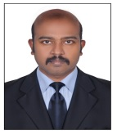
2 | 2618211977 | 1-11343476078 | Dr Veenaraja D / Asst. Prof. | 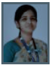
3 | 2617531993 | 1-44069081449 | Mrs Divya Anantharajan / Asst. Prof. | 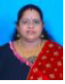
4 | 2653651992 | 1-44924867431 | T.Irin Gilda,& Assistant professor / Asst. Prof. | 
5 | 2610242000 | 1-47105874318 | Ms Narmadha U / Asst. Prof. | 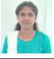
6 | 2667581989 | 1-47944141301 | Mrs Pauline Amertha Lithurin / Asst. Prof. | 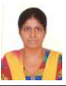
7 | 2688061995 | 1-43882027175 | Mrs. Anjali Devi G / Asst. Prof. | 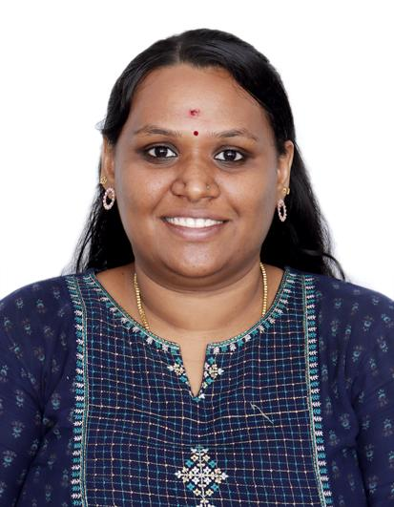
8 | 2622401994 | 1-720615521 | P.Pavithra & Assistant Professor | 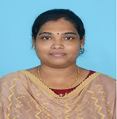
9 | 2670391991 | 1-44822208894 | Kanimozhy PS & Assistant Professor | 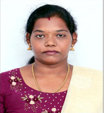
10 | 2660971990 | 1-3703302716 | Mrs Ilakkia Ganesan / Asst. Prof. | 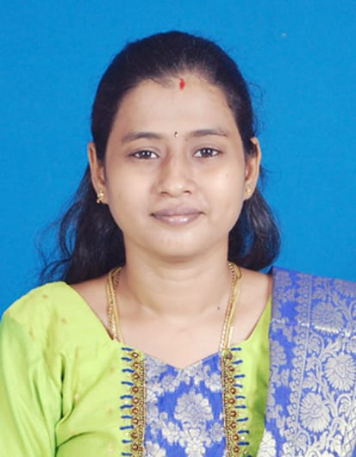

11 | 2681631991 | 1-47063132246 | Mrs Udhaya Kannusamy / Asst. Prof. | 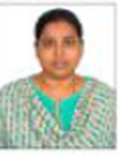
12 | 2674661989 | 1-43388488281 | Mrs Kavitha V / Asst. Prof. | 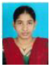
13 | 2627961989 | 1-47948449899 | Mr Narantran Ganesan / Asst. Prof. | 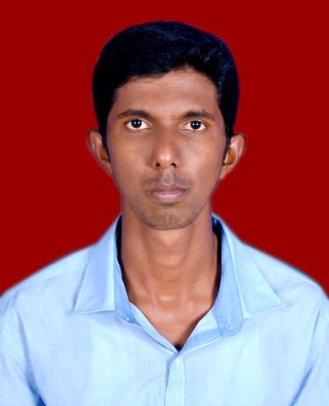
14 | 2764231990 | 1-47942537595 | Ms. Gowri G / Asst. Prof. | 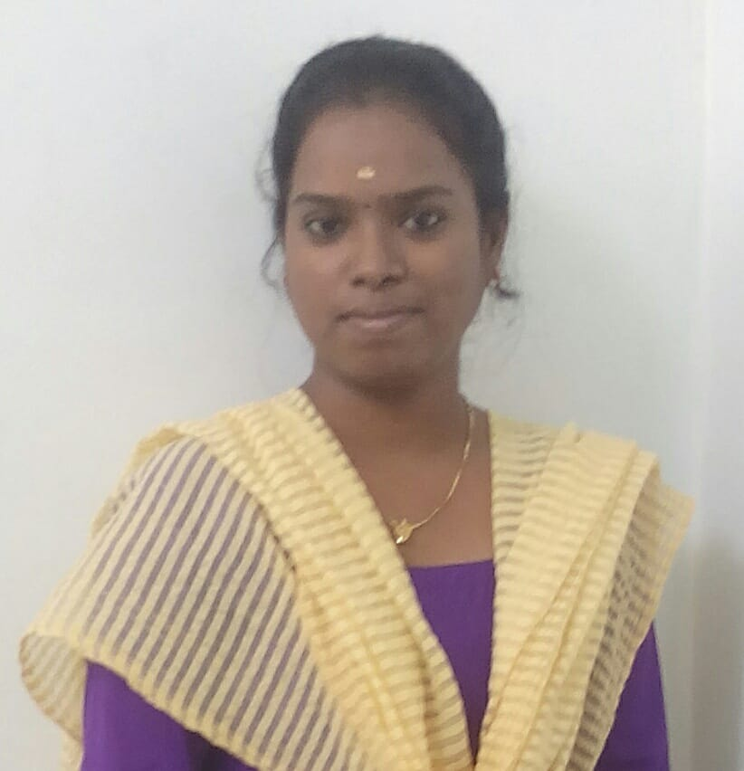
15

 |  |  | DMI COLLEGE OF ENGINEERING
 |  |  | PALANCHUR, CHENNAI – 123
DEPARTMENT OF ARTIFICIAL INTELLIGENC AND MACHINE LEARNING

FACULTY DETAILS
S.NO | AU - FIN | AICTE ID | NAME & DESIGNATION | PHOTO(PASSPORT SIZE)
1 | 2612461986 | 1-4708003222 | Dr. Jimson L,  Assistant Professor | 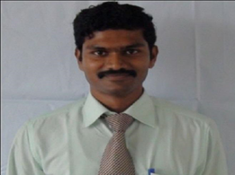
2 | 2616761989 | 1-44730552861 | Kishore Kumar K,  Assistant Professor | 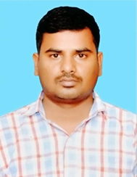
3 | 2620871993 | 1-44925083262 | Sherin Princy J  Assistant Professor | 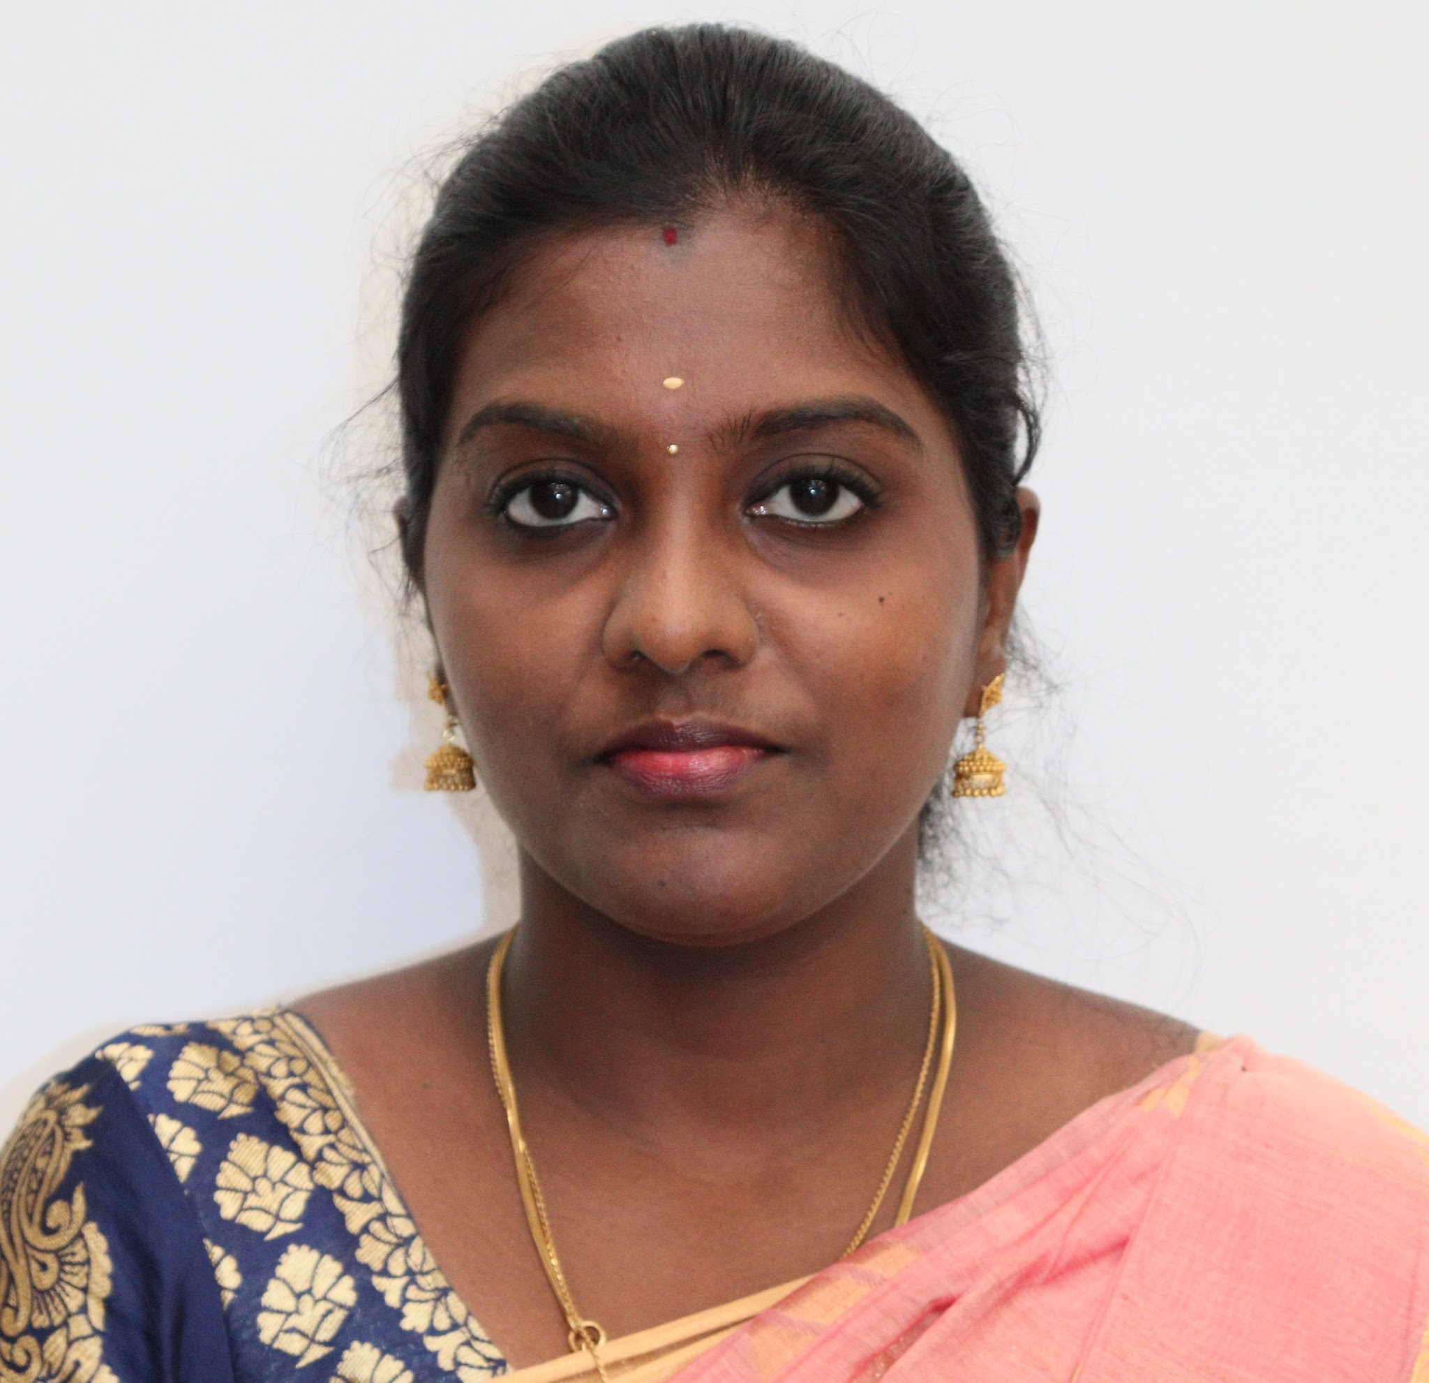
4 | 2696611995 |  | Indhumathi V ,  Assistant Professor | 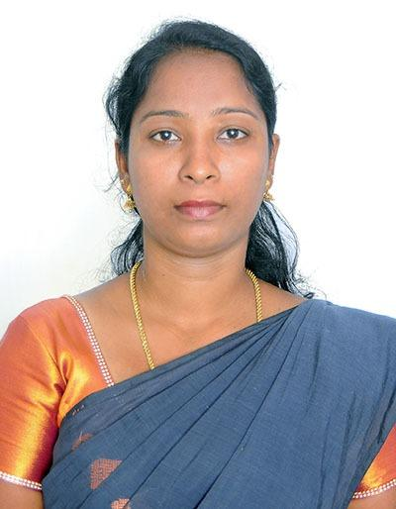

5 | 2692201993 | 1-8002208665 | KRISHNA VENI A  Assistant Professor | 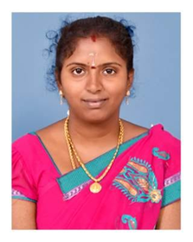
6 | 2679951977 | 1-46647645943 | Mini T  Assistant Professor | 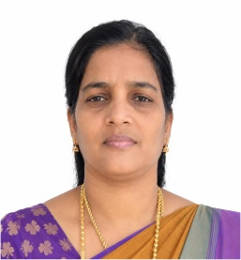
7 | 2680281992 | 1-44741492410 | Pushpa Sowmiya,  Assistant Professor | 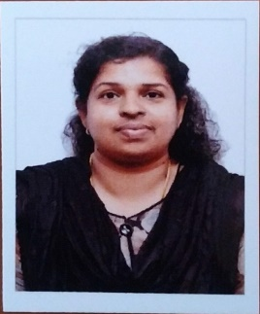
8 | 2628021993 | 1-45829702643 | Ms. Asha / Asst. Prof | 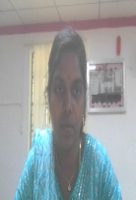
9 | 2648352000 | 1-47948963722 | Mrs PAVITHRA VIJAYAKUMAR  Asst. Prof

 |  |  | DMI COLLEGE OF ENGINEERING
 |  |  | PALANCHUR, CHENNAI – 123
DEPARTMENT OF COMPUTER SCIENCE AND ENGINEERING

FACULTY DETAILS
S.NO | AU - FIN | AICTE ID | NAME & DESIGNATION | PHOTO(PASSPORT SIZE)

1 | 2657131969 | 1-7838313018 | DR V SURESH KUMAR /  PROFESSOR | 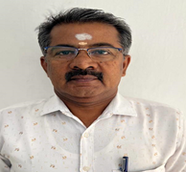
2 | 2614261967 | 1-3590563399 | DR LEO VIJILIOUS M A /  PROFESSOR | 
3 | 2621891982 | 1-43392694332 | DR. AGITHA W /  ASSOCIATE PROFESSOR | 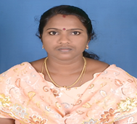
4 | 2670481987 | 1-2184524942 | MS. SWARNA LAKSHMI P /  NT PROFESSOR | 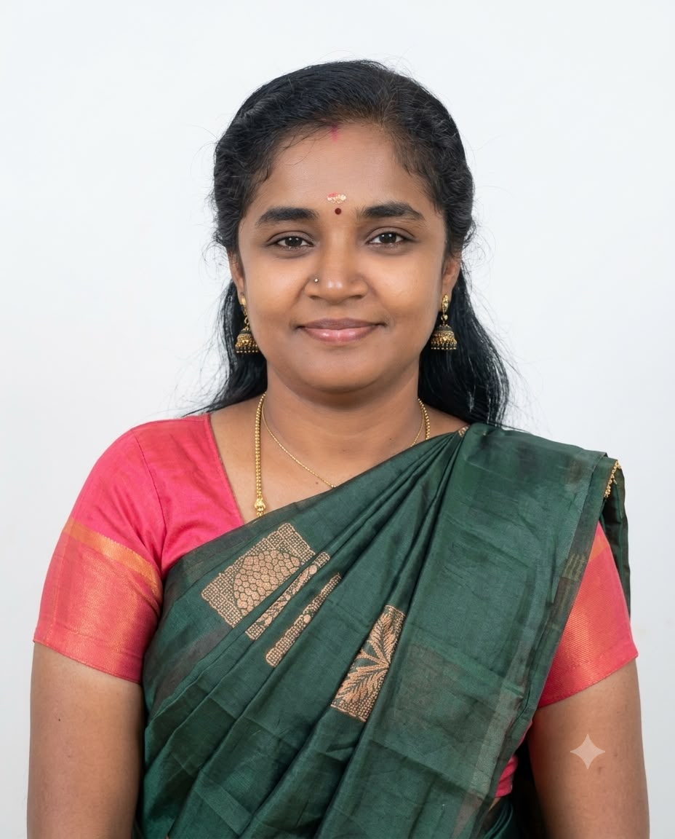

5 | 2686171982 | 1-4477365184 | MR ARIHARAN G /  ASSISTANT PROFESSOR | 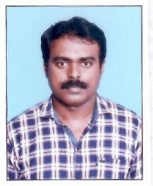
6 | 2692761997 | 1-10576164461 | MS. INDHUMATHI R /  ASSISTANT PROFESSOR | 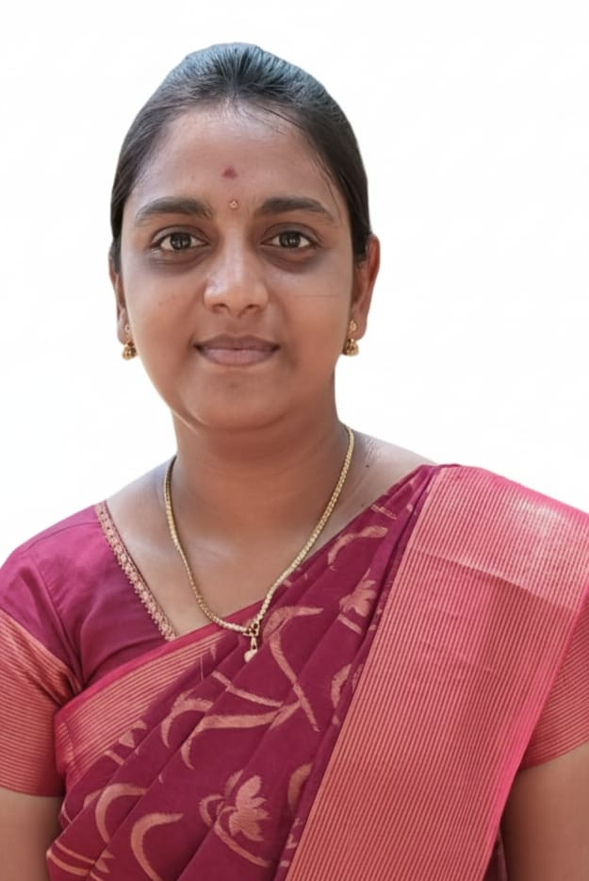
7 | 2648771984 | 1-7529231284 | MRS. LAVANYA R /  ASSISTANT PROFESSOR | 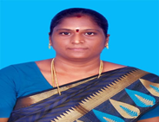
8 | 2669781988 | 1-9538985702 | MRS. NIRMALA B /  ASSISTANT PROFESSOR | 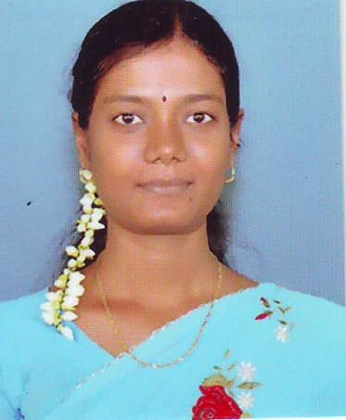
9 | 2659091978 | 1-43811107411 | MR. VIJAYAKUMAR V /  ASSISTANT PROFESSOR | 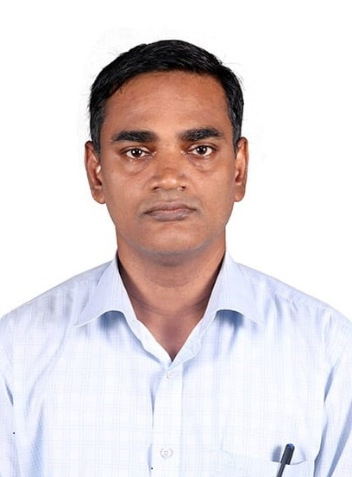

10 | 2681901999 | 1-44036068985 | MRS. SOWMIYA M / ASSISTANT PROFESSOR | 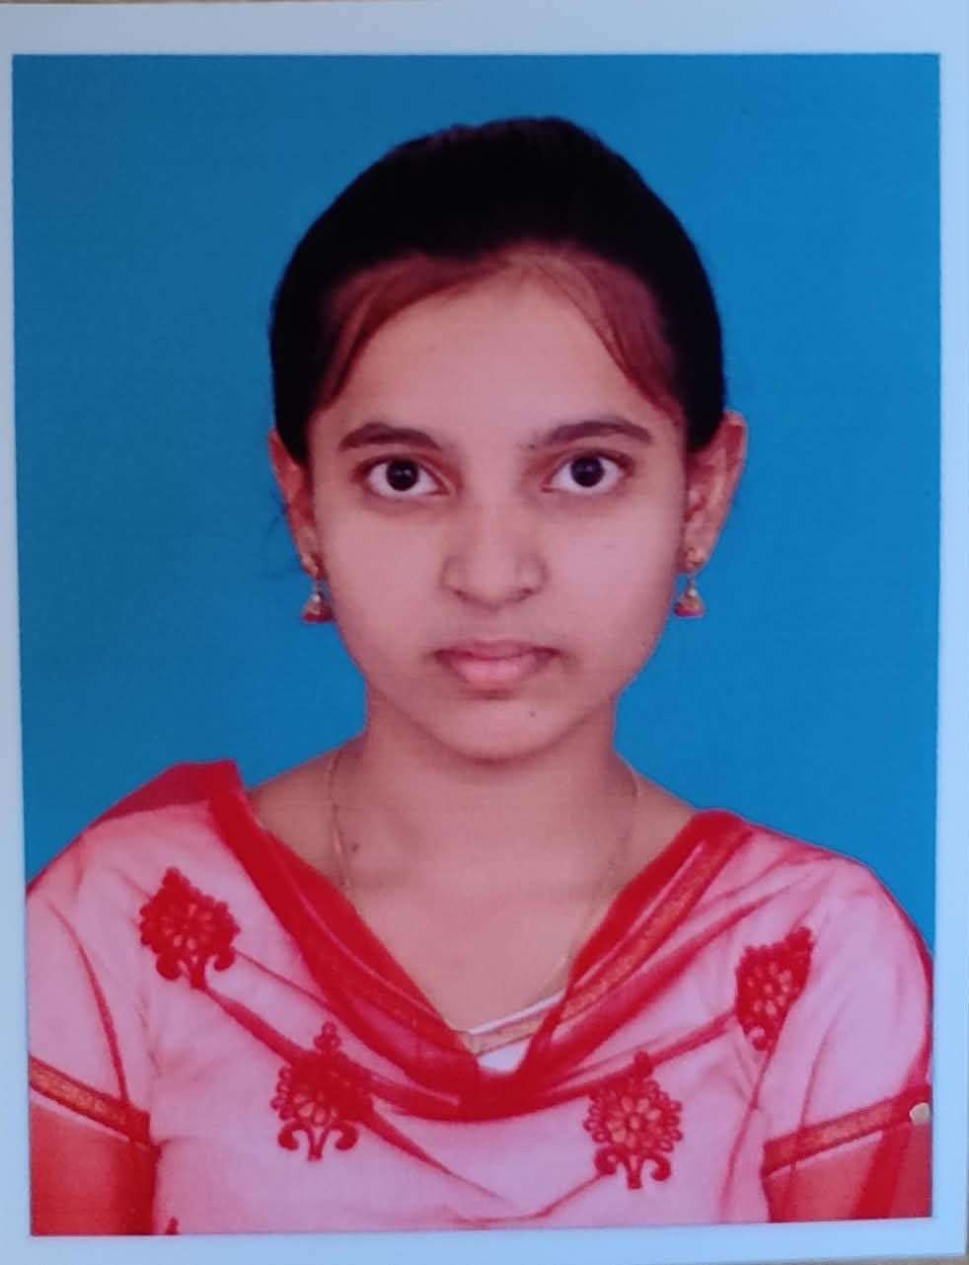
11 | 2685002001 | 1-47940629413 | MS. KEERTHANA B / ASSISTANT PROFESSOR | 
12 | 2611811987 | 1-45240670267 | MRS. NARMADHA / ASSISTANT PROFESSOR | 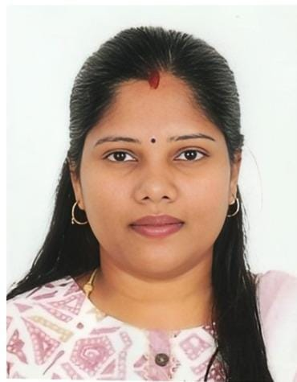
 | 2650581986 | 1-44048877510 | MRS. BALA SUBBU LAKSHMI / ASSISTANT PROFESSOR | 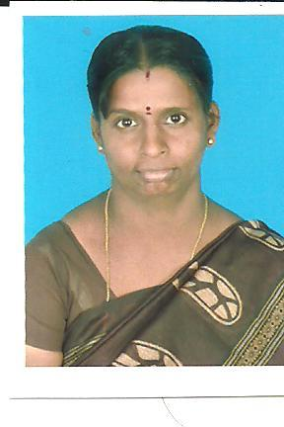
14 | 2690471986 | 1-47940629669 | MRS. RATHIKA P / ASSISTANT PROFESSOR | 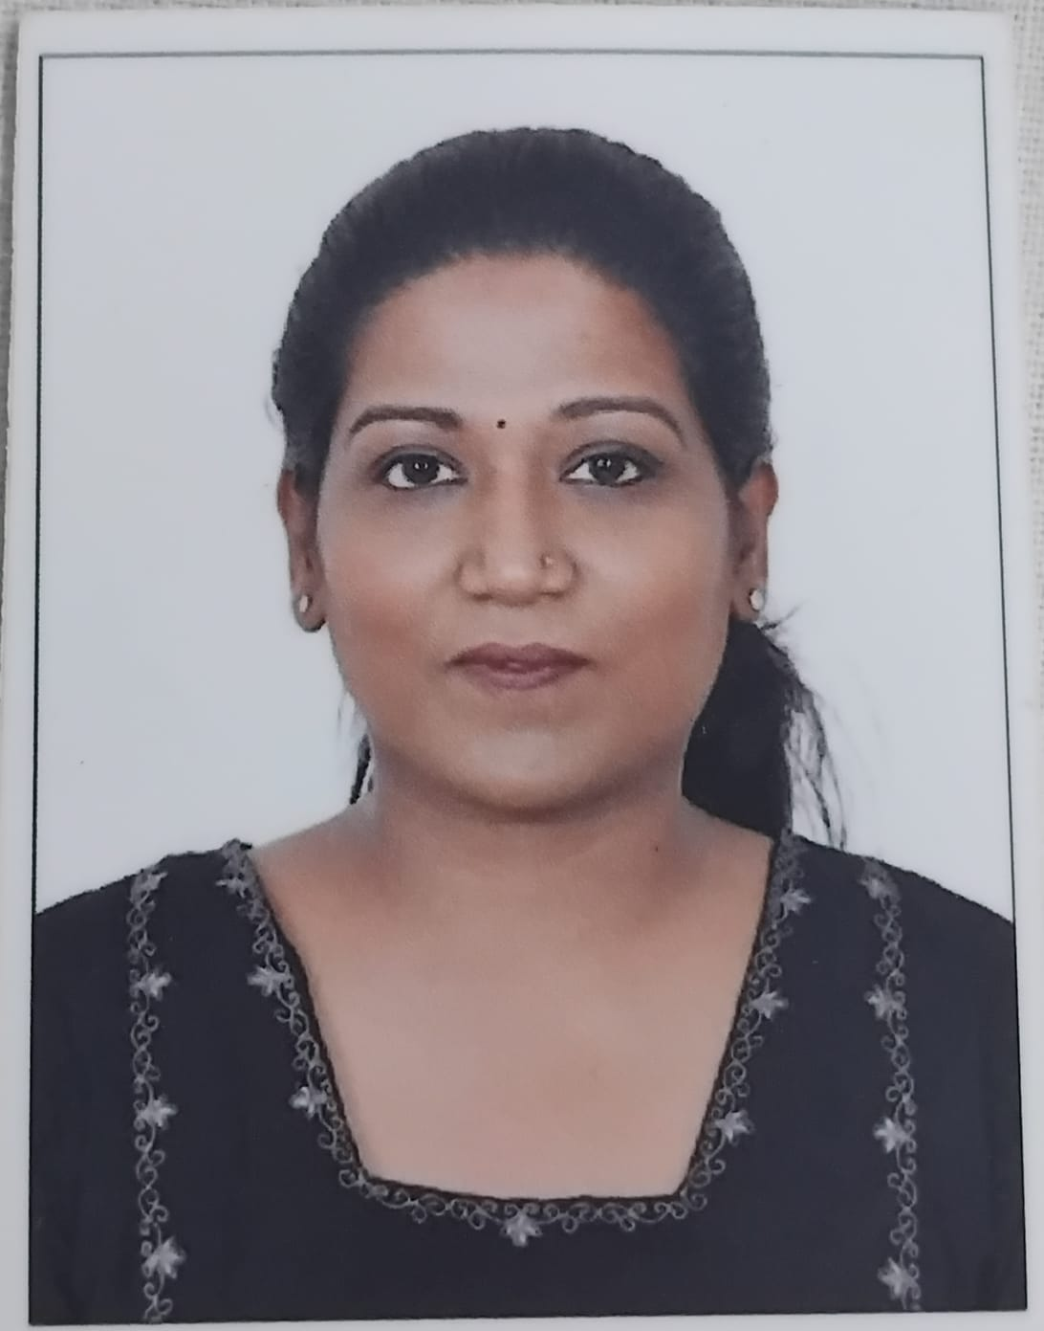
15 | 2757282001 | 1-47920596952 | MS. THILLAI / ASSISTANT PROFESSOR | 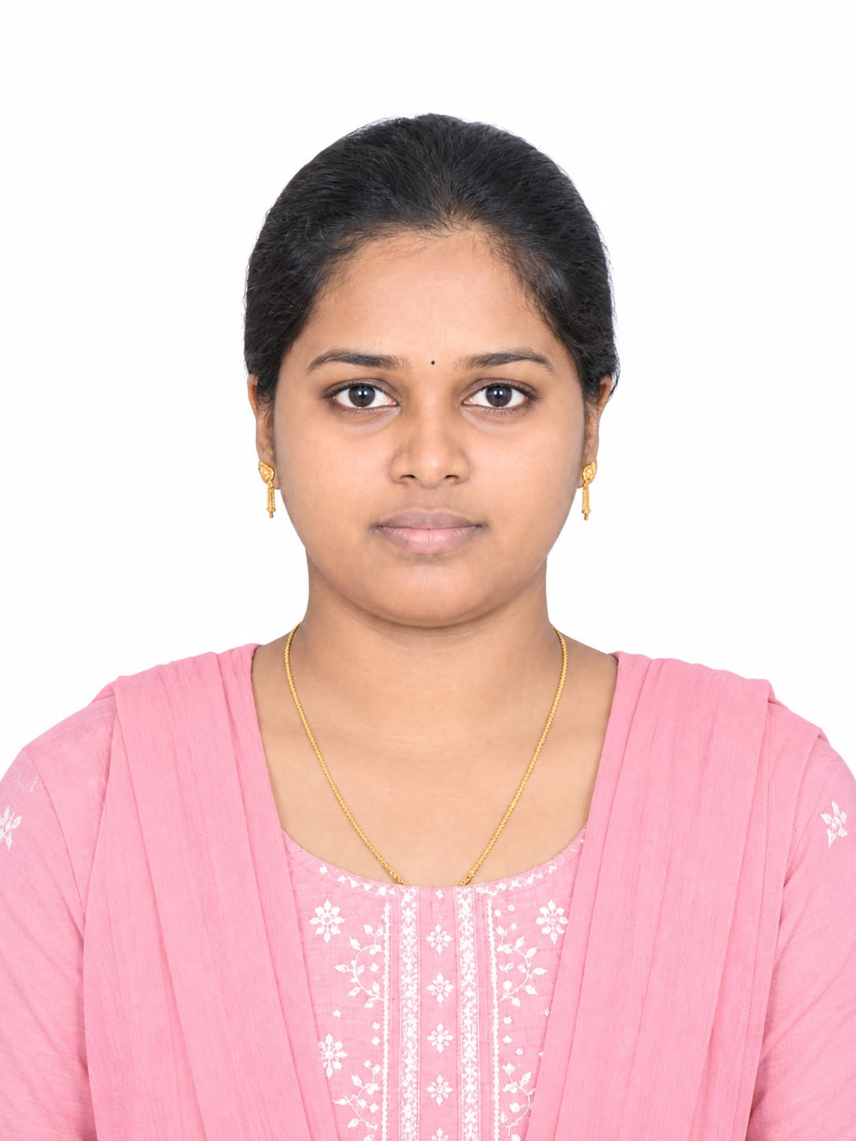

16 | 2613221994 | 1-44805169210 | MRS. MANJU PRIYA / ASSISTANT PROFESSOR | 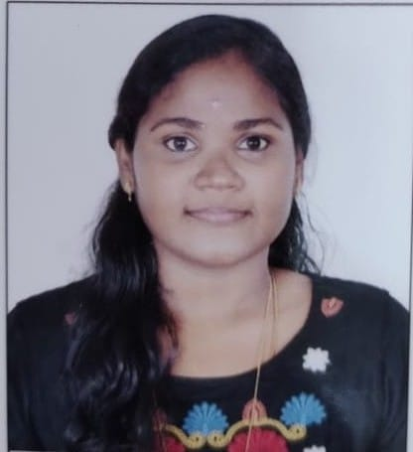
17 | 2623741989 | 1-44079843752 | MR ARUN MON / ASSISTANT PROFESSOR | 
18 | 2682121988 | 1-47036507154 | MRS NISHA MOL V / ASSISTANT PROFESSOR | 
19 | 2693851991 | 1-10566835771 | MRS. LAVANYA V / ASSISTANT PROFESSOR | 
20 | 2680991989 | 1-47940060379 | Mr A SINGSTON CHANDAR  Asst. Prof | 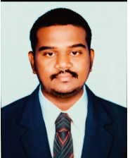

DMI COLLEGE OF ENGINEERING
PALANCHUR, CHENNAI – 123

DEPARTMENT OF CIVIL ENGINEERING

FACULTY DETAILS
S.NO | AU - FIN | AICTE ID | NAME & DESIGNATION | PHOTO(PASSPORT SIZE)
1 | 2672161990 | 1-7469351409 | P.M.Steffy Teena Thushara  Asst.Prof | 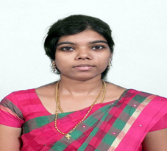
2 | 2693271993 | 1-44746203238 | G.Jebaraj  Asst.Prof | 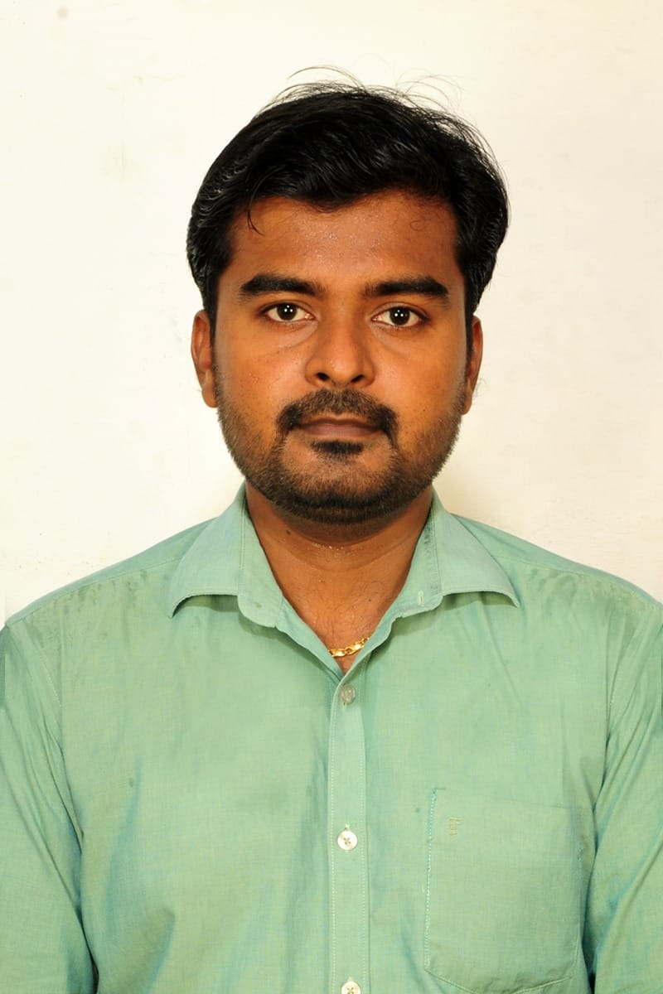
3 | 2696291988 | 1-2485485348 | M. Rajendiran  Asst.Prof | 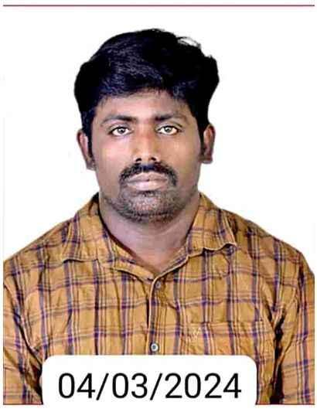
4 | 2669001993 | 1-4515705409 | Mrs HARIPRIYA G  Asst. Prof. | 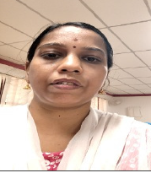

DMI COLLEGE OF ENGINEERING
PALANCHUR, CHENNAI – 123

DEPARTMENT OF ELECTRONICS AND COMMUNICATION ENGINEERING

FACULTY DETAILS
S.NO | AU - FIN | AICTE ID | NAME & DESIGNATION | PHOTO(PASSPORT SIZE)
1 | 2683701970 | 1-2487592748 | Dr. Sujatha Jamuna Anand ,  Professor & Principal | 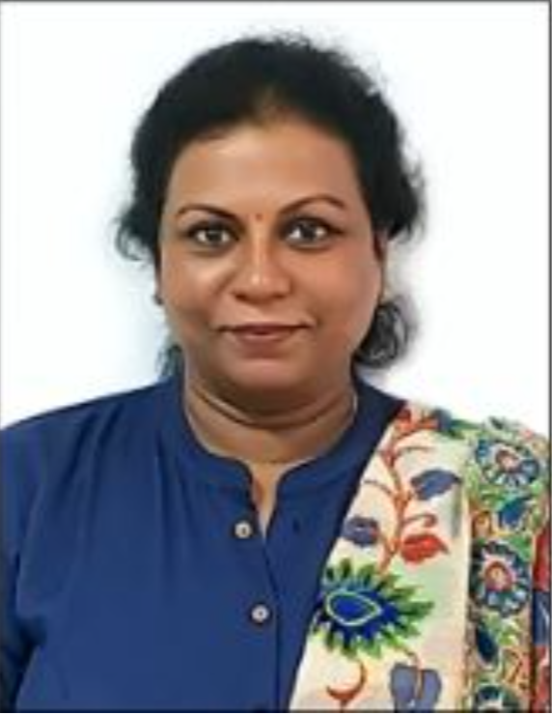
2 | 2639031976 | 1-44121986940 | Dr. L. M. Merlin Livingston  Professor | 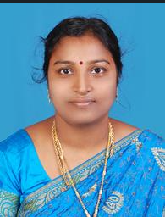
3 | 2682881977 | 1-455766990 | Dr. K G Revathi  Professor | 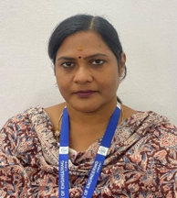
4 | 2632061989 | 1-4734871 | Dr. R. Dinesh Kumar  Professor & Head | 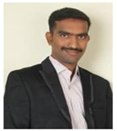
5 | 2645041985 | 1-474111737 | Mrs. Shally S P  Assistant Professor | 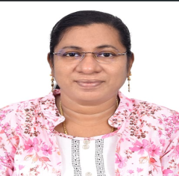
6 | 2669571984 | 1-43816527357 | Mrs.Vinodha N  Assistant Professor | 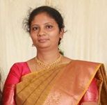
7 | 2644311992 | 1-44035540801 | Mrs. K K Devi Sowndarya  Assistant Professor | 
 | 2633951990 | 1-11334497775 | Mrs Jasmine Ananthi M  Assistant Professor | 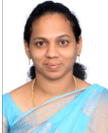
9 | 2615281988 | 1-2191485571 | Mrs.Bright Thanga Mahizh  Assistant Professor | 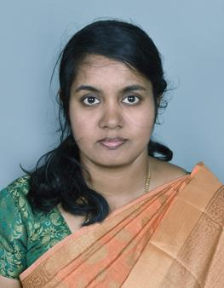
10 | 2672061991 | 1-448227598898 | Mrs.S.Savitha  Assistant Professor | 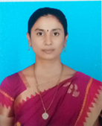
11 | 2622501986 | 1-741462125 | Ms.Preethi Vinnarasi A  Assistant Professor | 
12 | 2795941989 | 1-143357542373 | Dr. R. Sindhuja  Assistant professor | 
13 |  | 1-7472076181 | Ms.M.Sahini Piriya  Assistant Professor | 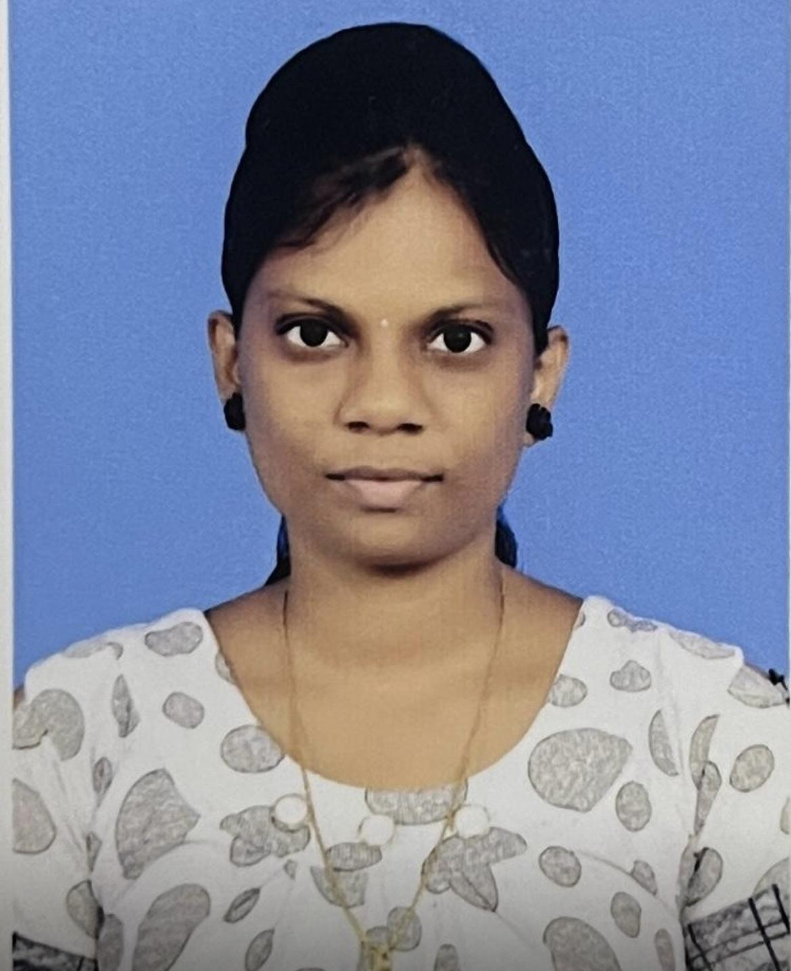
14 | 2650521997 | 1-44722370094 | Mrs.K.L.Muthamizh  Assistant professor | 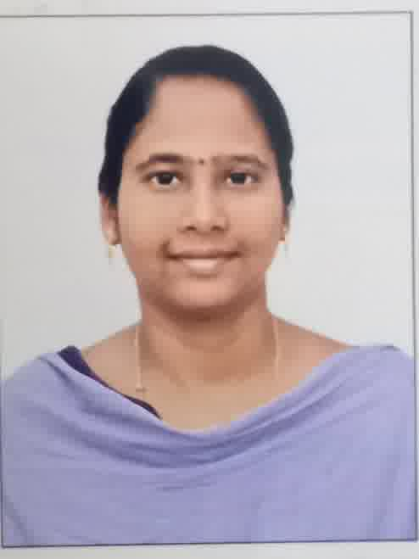

DMI COLLEGE OF ENGINEERING
PALANCHUR, CHENNAI – 123

DEPARTMENT OF ELECTRICAL AND ELECTRONICS ENGINEERING

FACULTY DETAILS
S.NO | AU - FIN | AICTE ID | NAME & DESIGNATION | PHOTO(PASSPORT SIZE)
1 | 2624341980 | 1-43411754585 | Dr. SENTHIL RAMA  Professor | 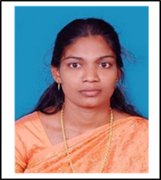
2 | 2657211981 | 1-7469428451 | DR SAI RAM T D  Professor | 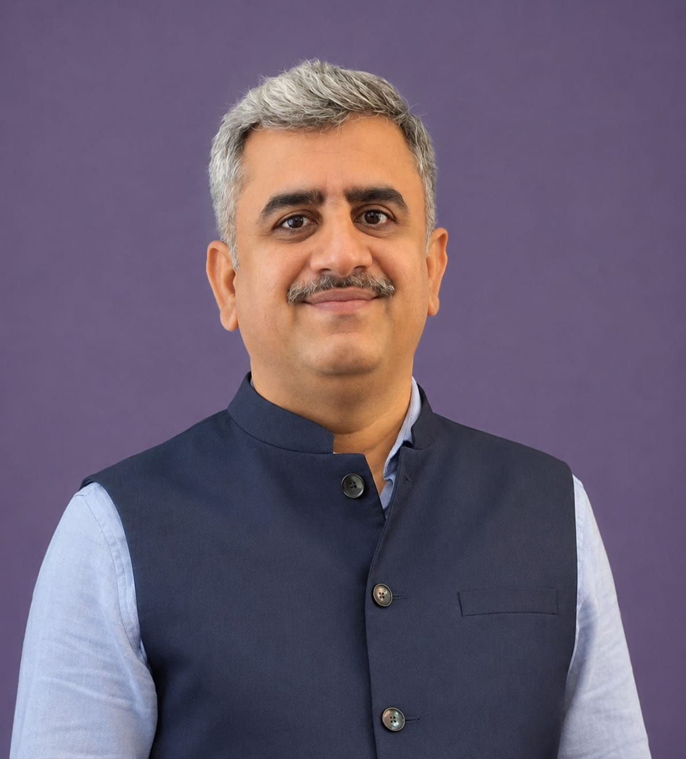
3 | 2619131968 | 1-449982469 | DR KARTHIKAYAN  Professor | 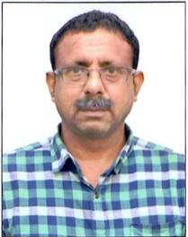
4 | 2666171982 | 1-461340654 | G.Vijaya  Assistant Professor | 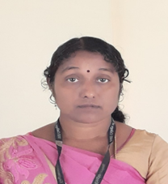
5 | 2645131985 | 1-4642870958 | G Chandran  Assistant Professor | 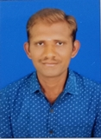
6 | 2644051998 | 1-43392420762 | MONIKA G  Assistant Professor | 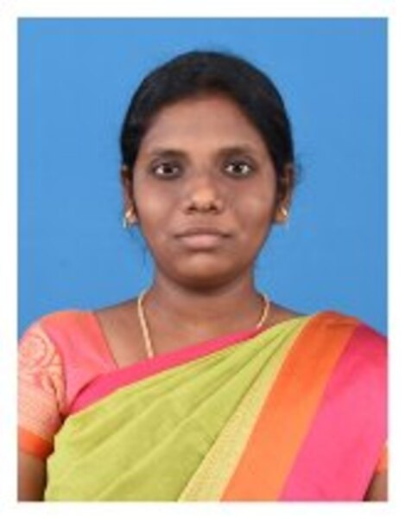
7 | 2662361999 | 1-45339450162 | JENIFER K  Assistant Professor | 
8 | 2674661989 | 1-2709307135 | D.Kavitha  Asst.Prof | 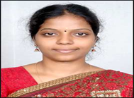
9 | 2699021990 | 1-47940495492 | M.S. Ushanandhini  Asst. Prof | 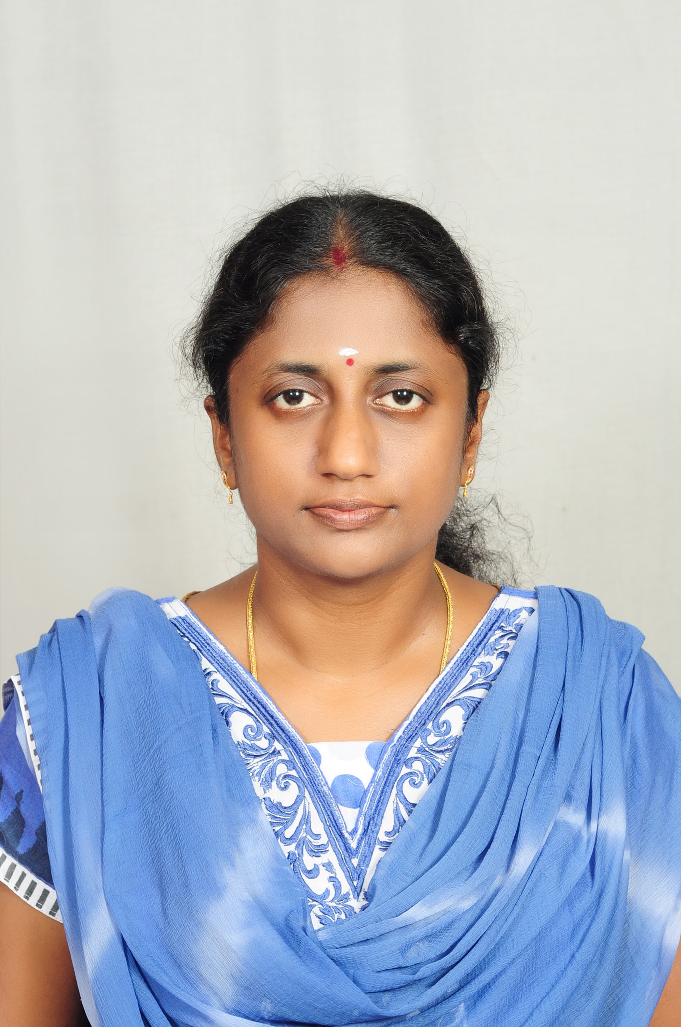

10 | 2687801990 | 1-7517996918 | MALARVIZHI.E  Asst.Prof | 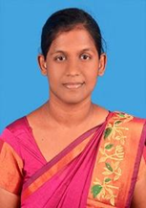
11 | 2642161990 | 1-4600619569 | M PRABAKARAN / AP | 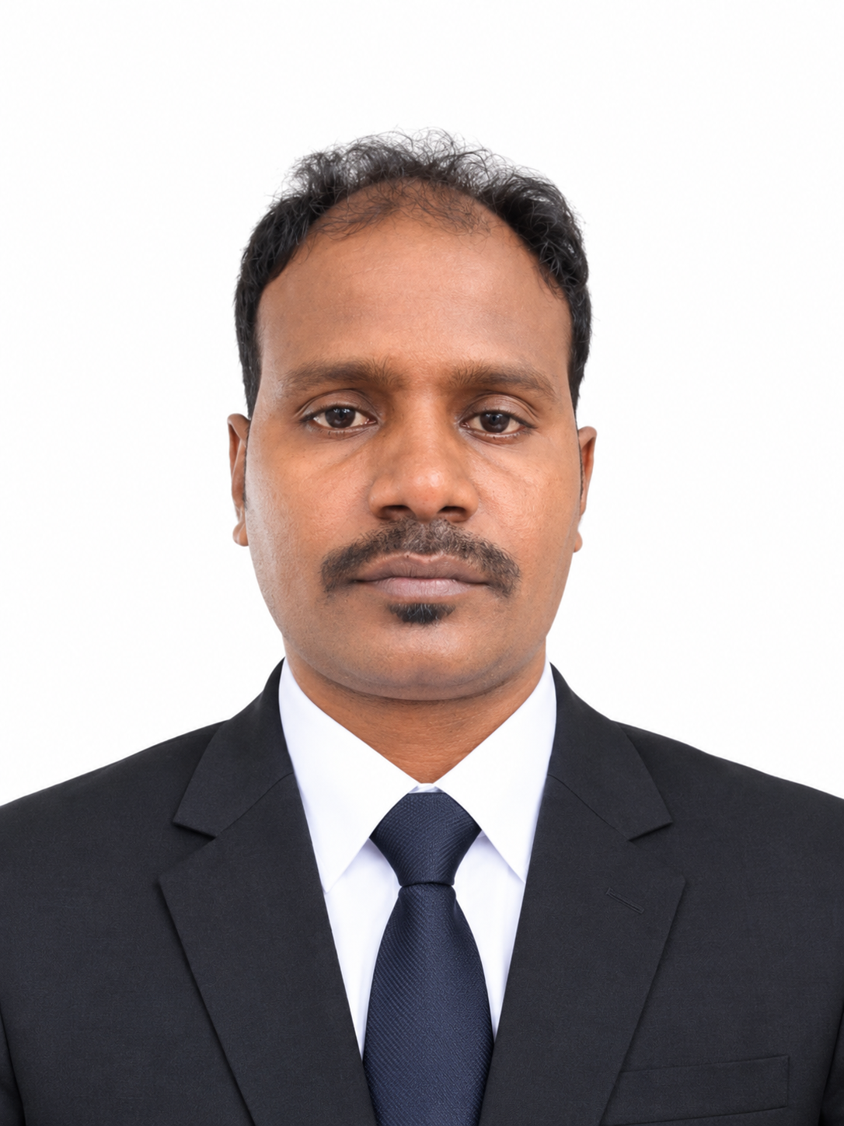

DMI COLLEGE OF ENGINEERING
PALANCHUR, CHENNAI – 123

DEPARTMENT OF MECHANICAL ENGINEERING

FACULTY DETAILS
S.NO | AU - FIN | AICTE ID | NAME & DESIGNATION | PHOTO(PASSPORT SIZE)
1 | 2675431969 | 1-7434601048 | Dr. N. Azhagesan,  Professor | 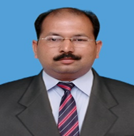
2 | 2678881973 | 1-10553150588 | Dr. V.L. Raja,  Professor | 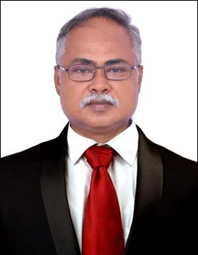
3 | 2629551968 | 1-9466971972 | Dr. V.N. Anbazhagan,  Associate Professor | 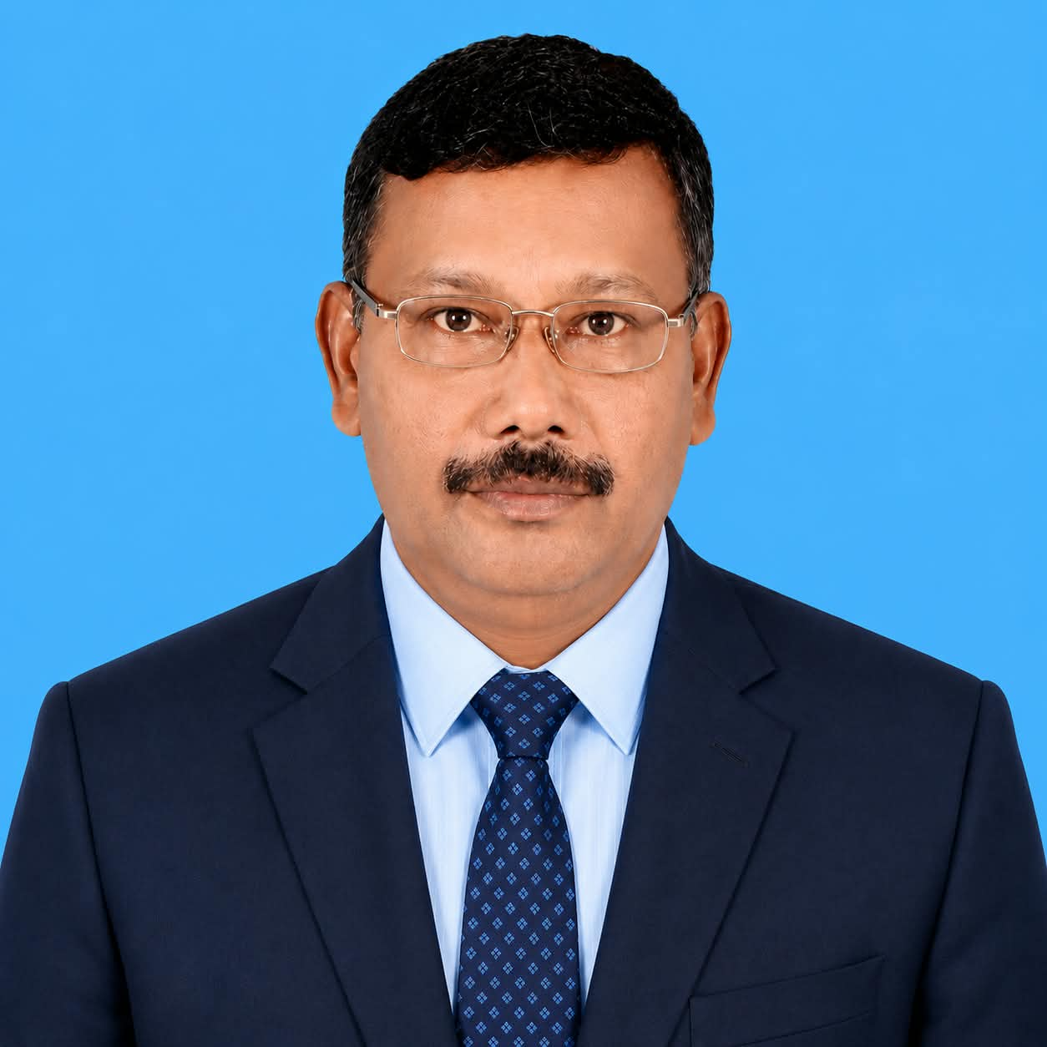
4 | 2672011982 | 1-2690750725 | Dr. G. Tamil Kumaran,  Assistant Professor | 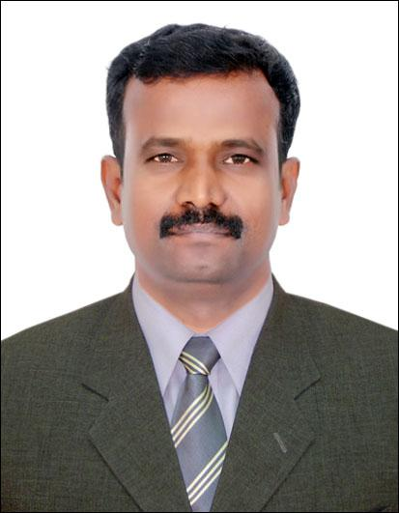
5 | 2689941981 | 1-2690750697 | Mr. Rajamahendran S,  Assistant Professor | 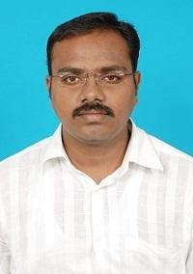
6 | 2651961987 | 1-2691328191 | Mr. Kaniraj S. O,  Assistant Professor | 
7 | 2696141985 | 1-3356804088 | Mr. Saravanan P,  Assistant Professor | 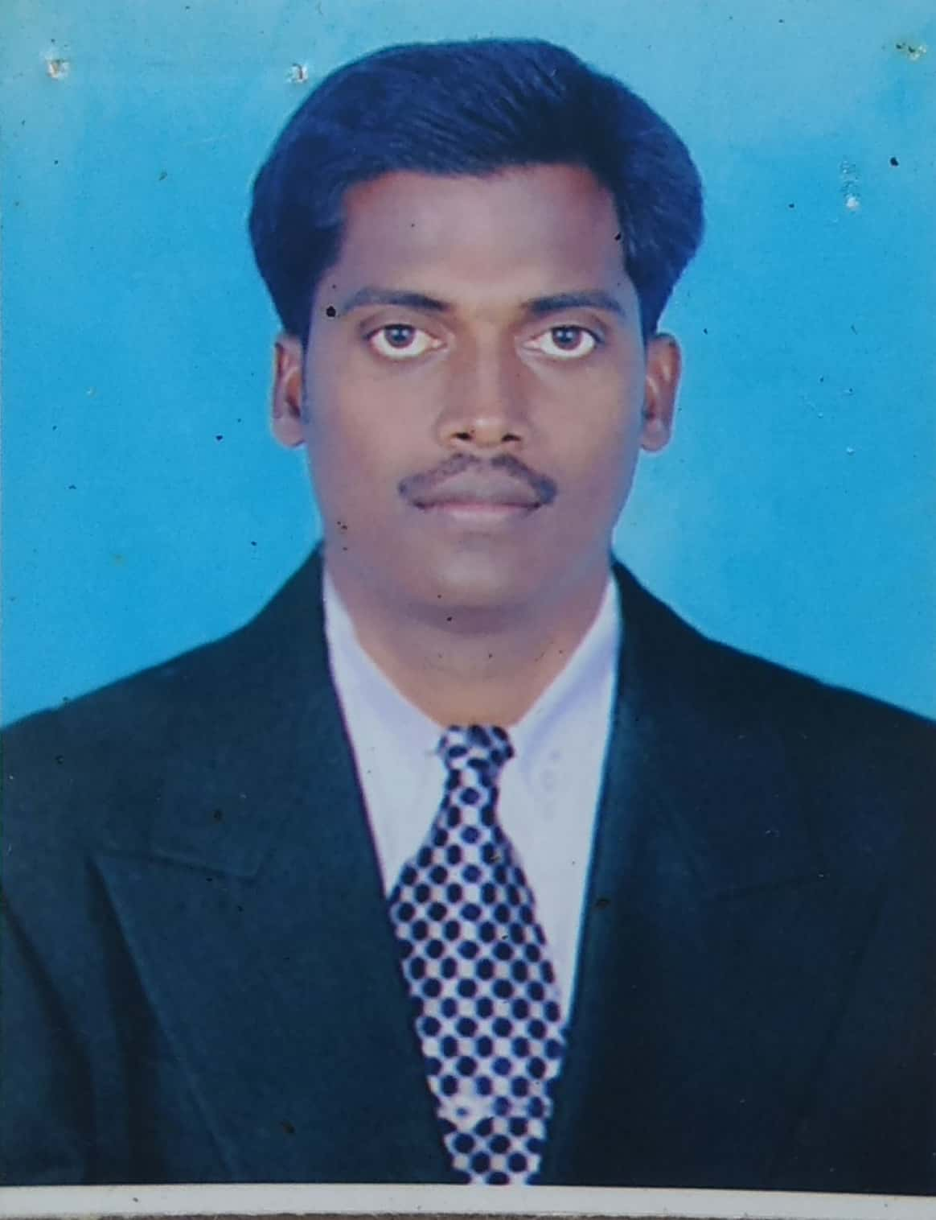
8 | 2632701989 | 1-2690750631 | Mr. Venkatesh R,  Assistant Professor | 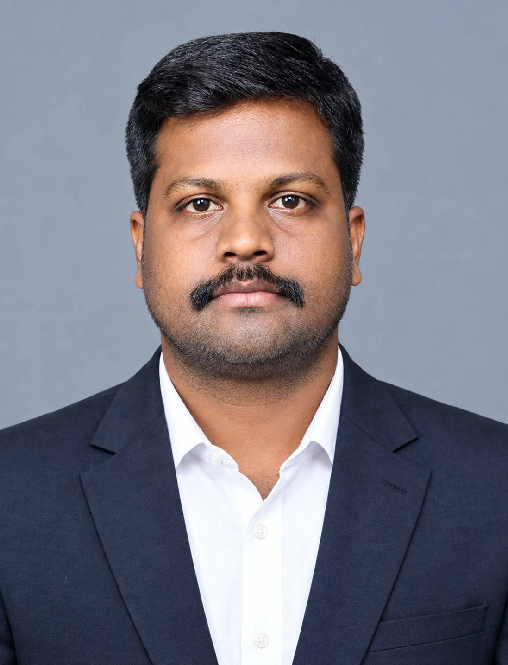
9 | 2660971986 | 1-7585426933 | Mr. Senthilkumaran M,  Assistant Professor | 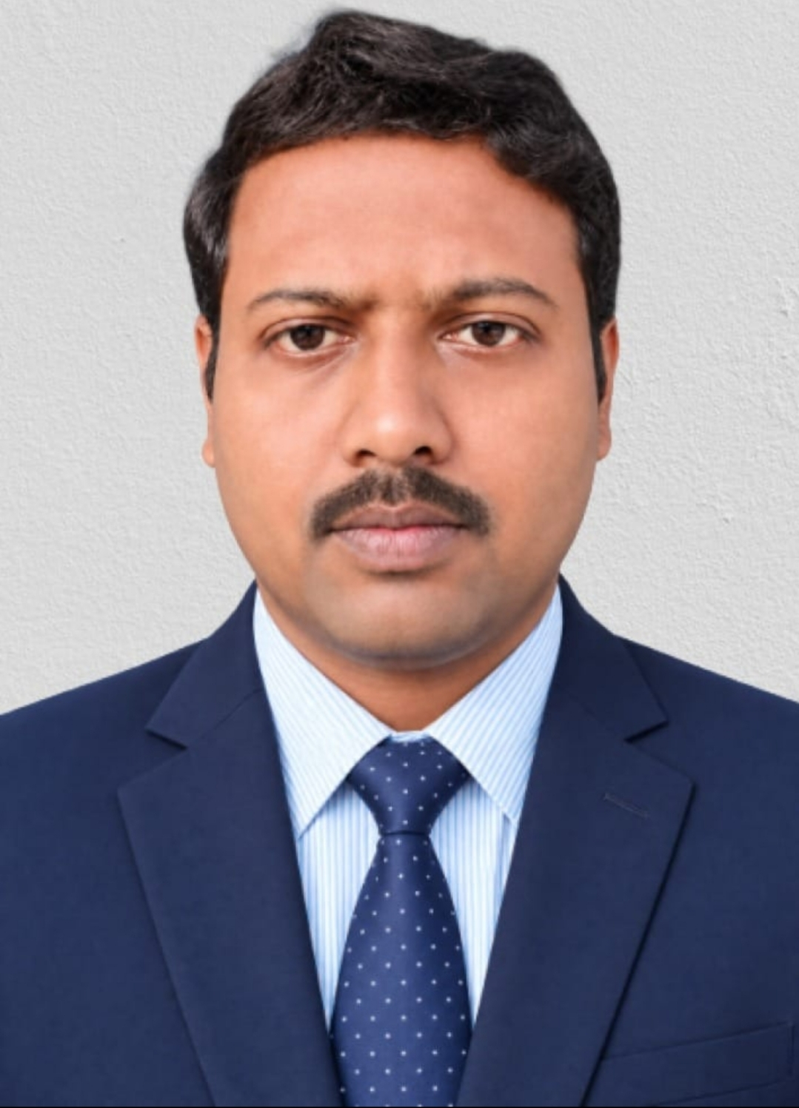

10 | 2667131991 | 1-44726779144 | Mr. Elwith J,  Assistant Professor | 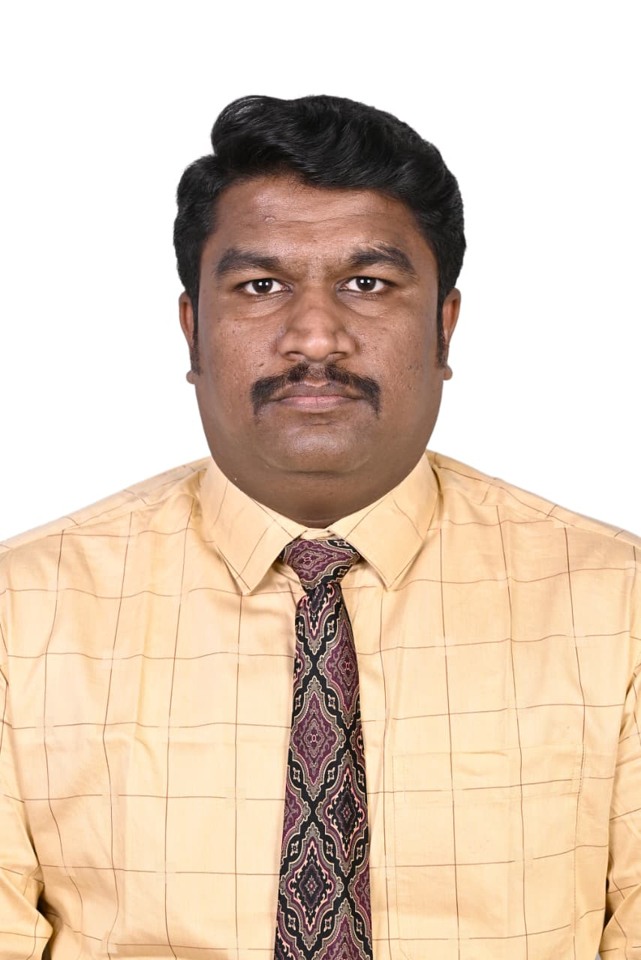

DMI COLLEGE OF ENGINEERING
PALANCHUR, CHENNAI – 123

DEPARTMENT OF INFORMATION TECHNOLOGY

FACULTY DETAILS
S.NO | AU - FIN | AICTE ID | NAME & DESIGNATION | PHOTO(PASSPORT SIZE)
1 | 2694391982 | 1-12193291149 | S.Mary Diana  Asst. Prof. | 
2 | 2692401990 | 1-3591921564 | Jenifer J  Asst. Prof | 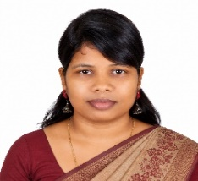
3 | 2612621982 | 1-43652352240 | A.DEEPA  Asst. Prof | 
4 | 2733942003 | 1-47940629372 | DHINESHBALAN N  Asst. Prof | 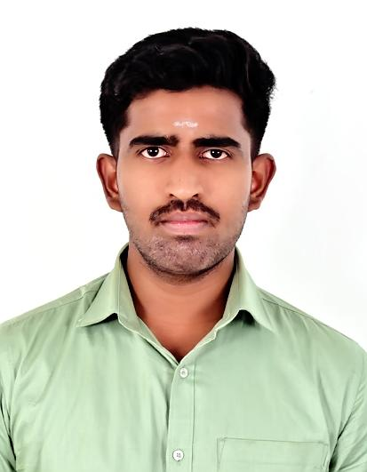
5 | 2673161987 | 1-43832968870 | DIVYA K  Asst. Prof | 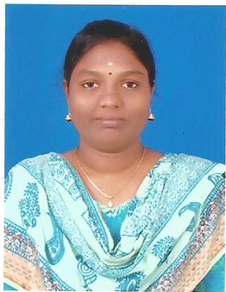
6 | 2617131990 | 1-43408834015 | Sylviya Sharon  Asst. Prof | 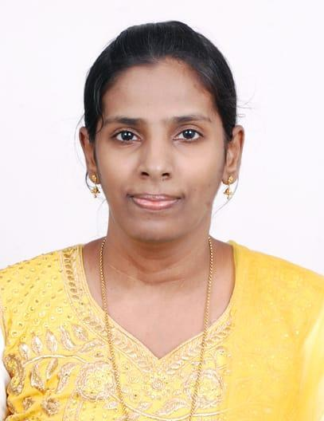

7 | 2614981990 | 1-47940629380 | Ajish H  Asst. Prof | 
8 | 2623171989 | 1-47940629387 | Vijay Daniel J  Asst. Prof | 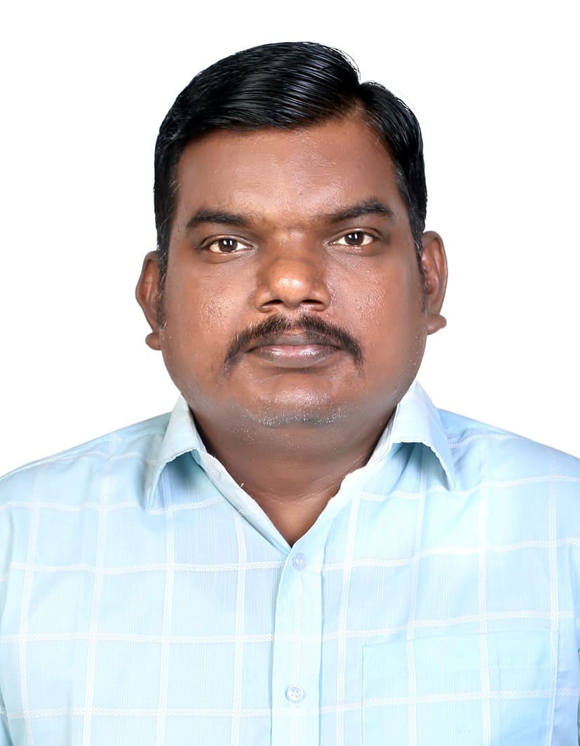
9 | 2644321992 | 1-47940629398 | Deepika M  Asst. Prof | 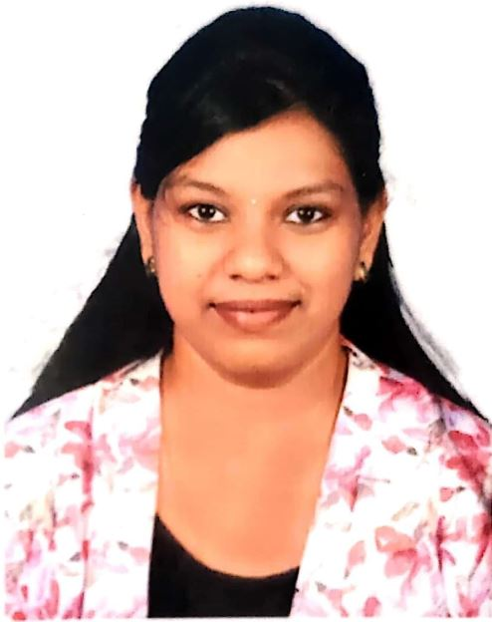
10 | 2695002002 | 1-47940629406 | ESWARI S & AP  Asst. Prof | 
11 | 2680551990 | 1-43816976671 | Mrs SUBHA SP | 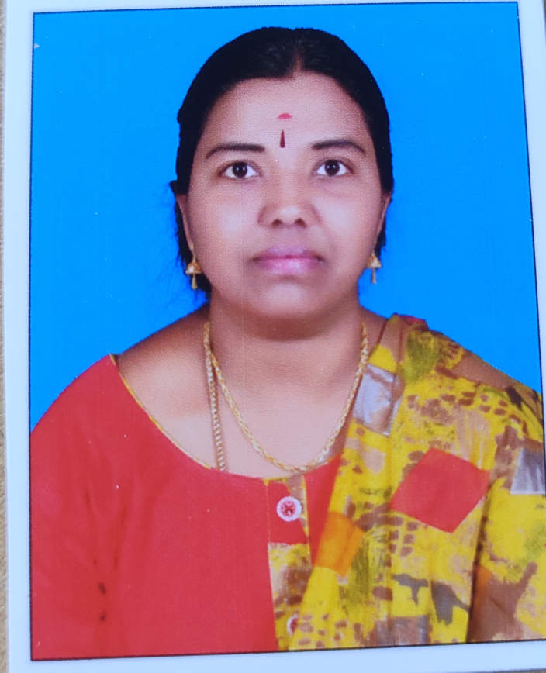
12 | 2645111982 | 1-9469924004 | Ms HAMLET B | 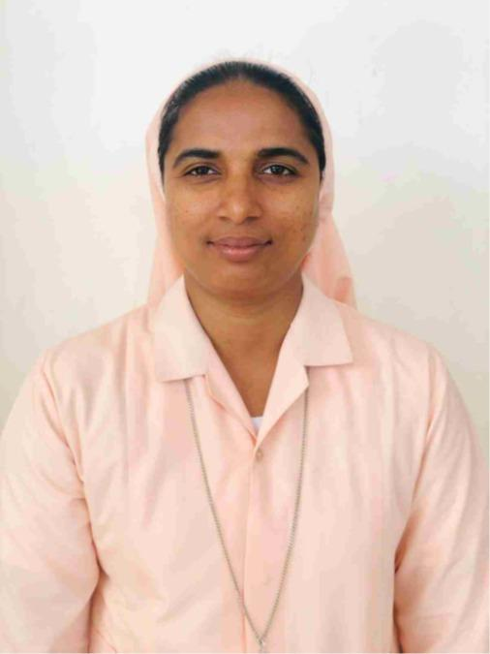

DMI COLLEGE OF ENGINEERING
PALANCHUR, CHENNAI - 123
DEPARTMENT OF MASTER OF BUSINESS ADMINISTRATION
FACULTY DETAILS
S.NO |  | AU - FIN | AICTE ID | NAME & DESIGNATION | PHOTO(PASSPORT SIZE)
1 | 2633241987 |  | 1-44726791254 | Mrs. Amy Susan  Asst. Professor | 
2 | 2633121991 |  | 1-4393202212 | Mrs MICHEAL RASHMA M  Assistant Professor | 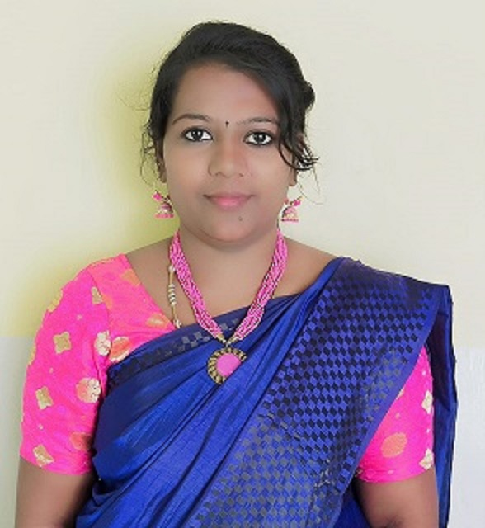
3 | 2725512000 |  | 1-47920194722 | Ms Angel Georgia Mary J,  Assistant Professor | 
4 | 2630771977 |  | 1-44925600982 | Ms SELIN MARY A  Assistant Professor | 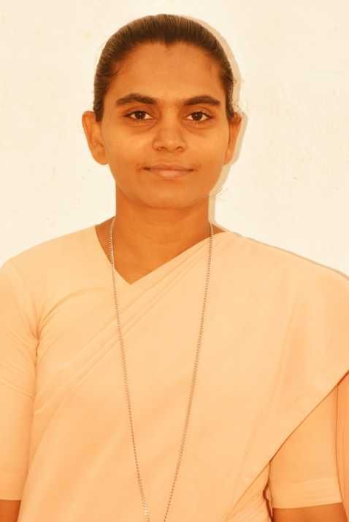
5 | 2626741999 |  | 1-45471991262 | Benisha M  Asst. Prof | 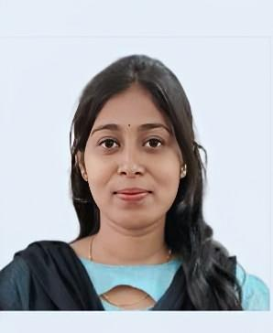
6 | 2655111976 |  | 1-9469923997 | Ms XAVIER SELVI  Assistant Professor | 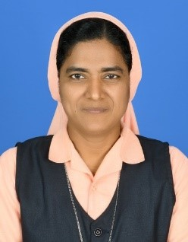
7 | 2671581969 |  |  | Dr. Chinnathambi  Professor | 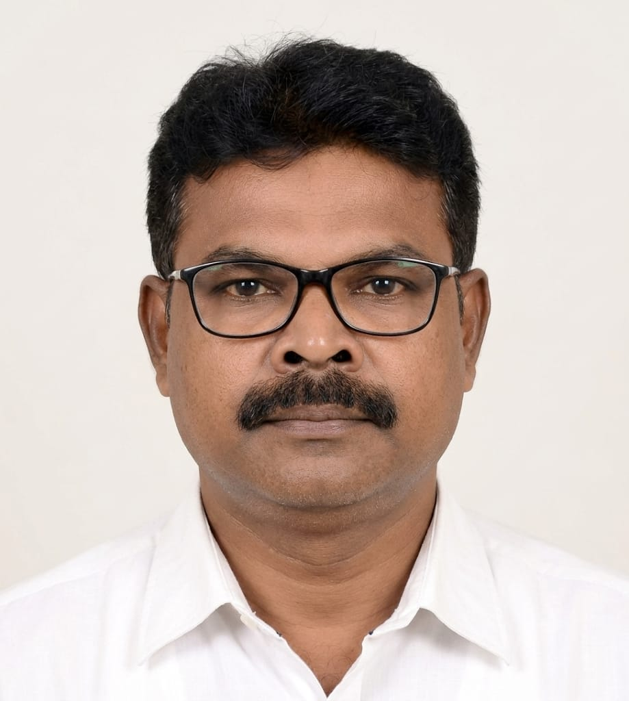
8 | 2753492001 |  | 1-47948709822 | Ms. Shilpa. R  Asst.Professor | 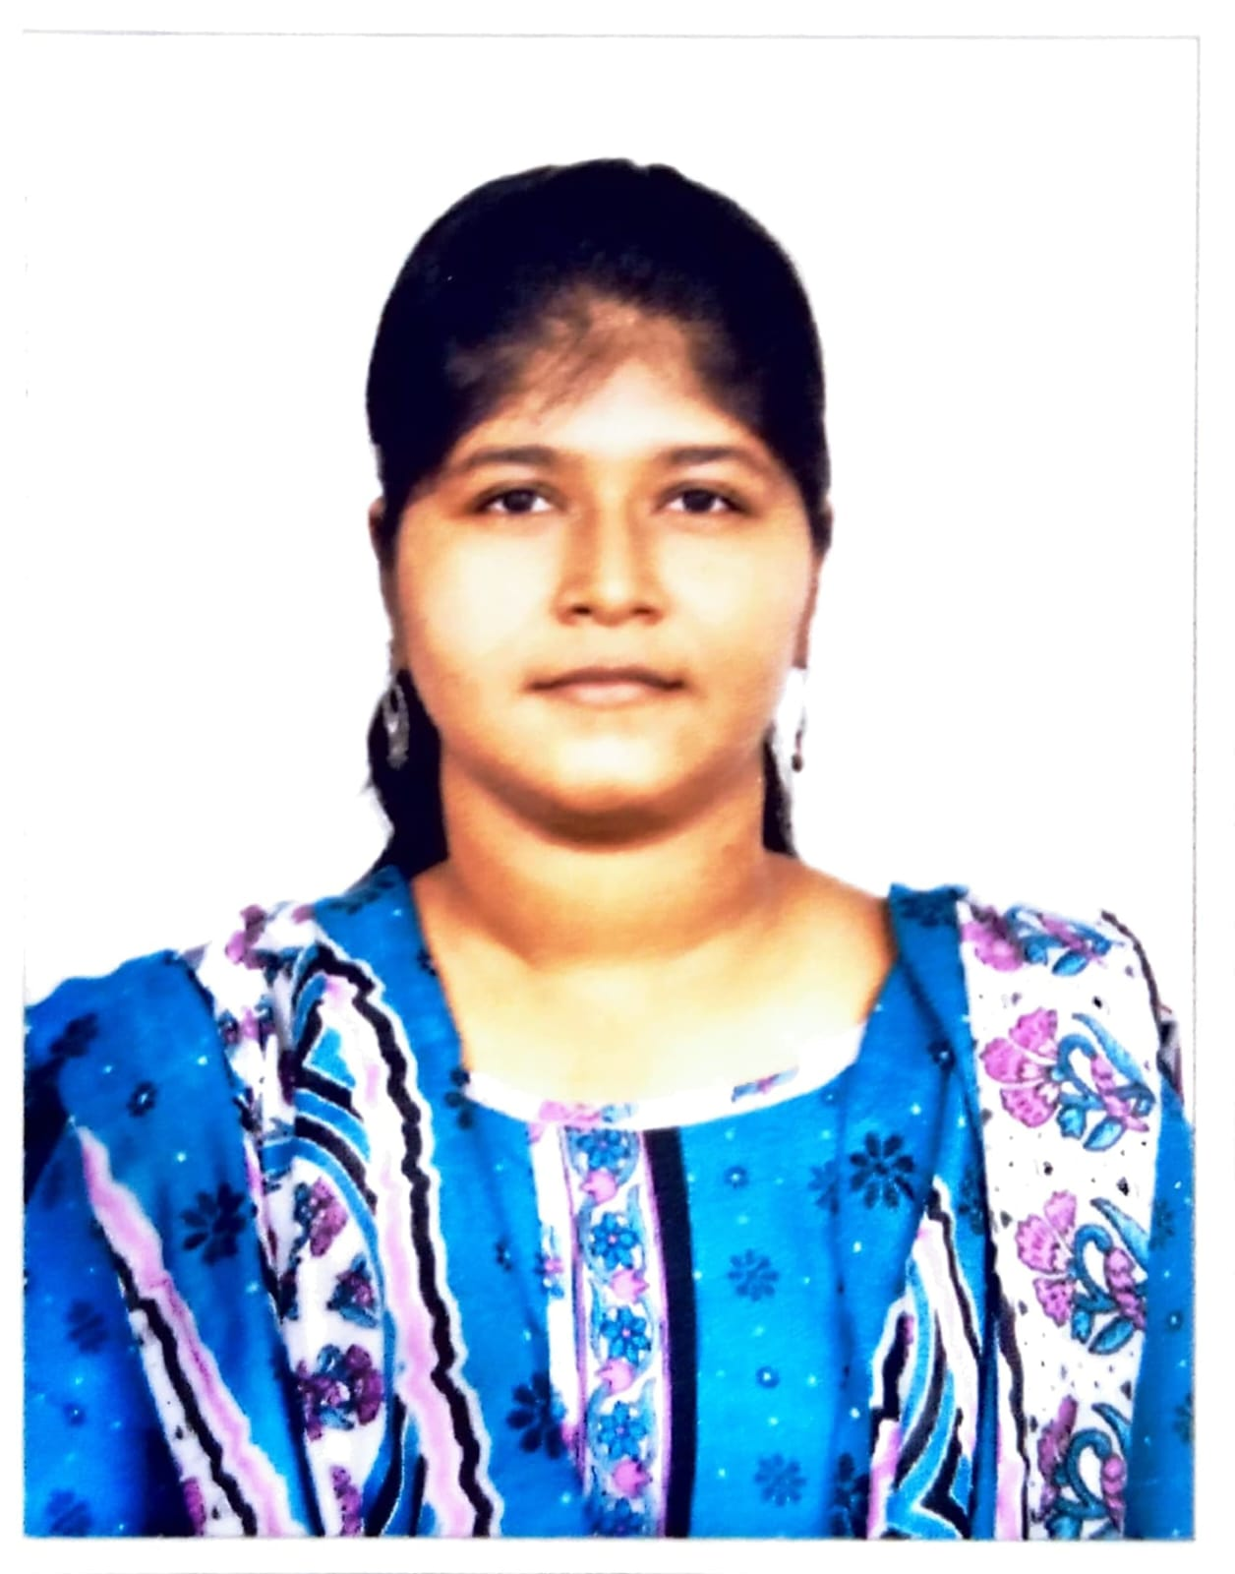

DMI COLLEGE OF ENGINEERING
PALANCHUR, CHENNAI - 123
DEPARTMENT OF SCIENCE AND HUMANITIES
FACULTY DETAILS
S.NO | AU - FIN | AICTE ID | NAME & DESIGNATION | PHOTO(PASSPORT SIZE)
1 | 2635021969 | 1-1509247166 | Dr CHITHRA DEVI S,  Professor | 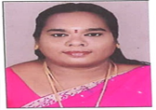
2 | 2683891975 | 1-44731253224 | Dr VISHNUPRIYA VENKATASESHAN Associate Professor | 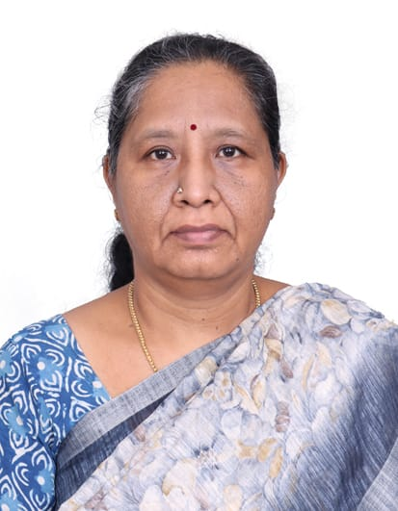
3 | 2691211967 | 1-499311331 | Dr IMMACULATE GEETHA,  Professor | 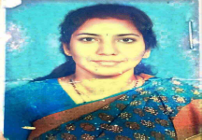
4 | 2620431987 | 1-4530321593 | Dr PRAKASH S M,  Associate Professor | 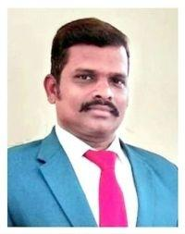
5 | 2620431987 | 1-9322296251 | Dr PETCHIAMMAL,  Assistant Professor | 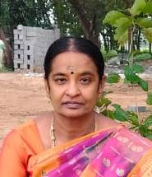
6 | 2654341994 | 1-11308753509 | Dr ANBARASAN V,  Assitant Professor | 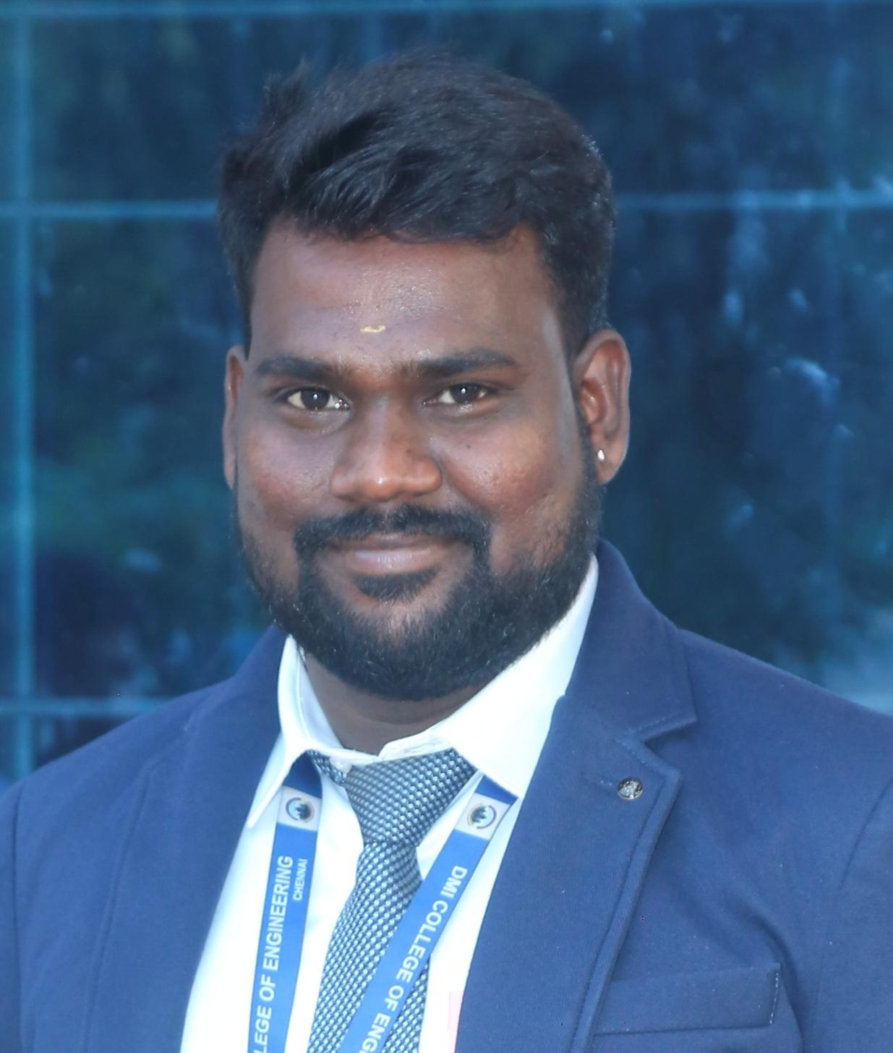

7 | 2677241985 | 1-9466467782 | Dr ANANTHARAMAN S,  Assistant Professor | 
8 | 2659481979 | 1-44725615714 | Dr EVANGELINE JONES JOY K, Assistant Professor | 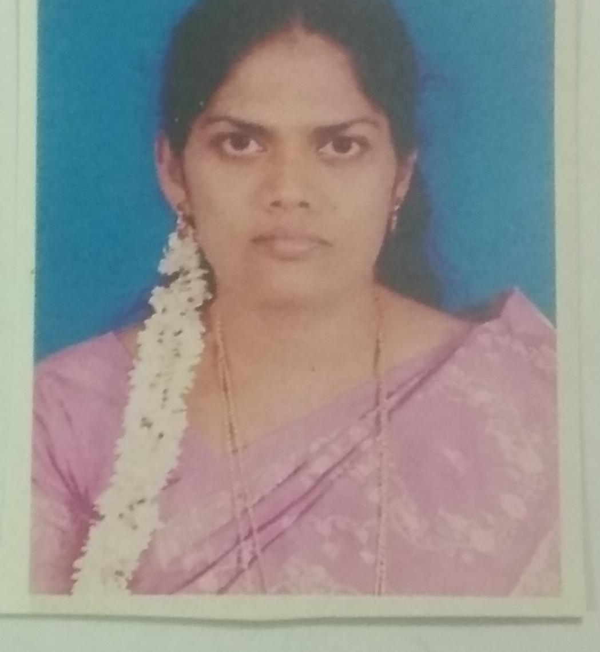
9 | 2689911993 | 1-44924088163 | Dr PANIMOZHI S,  Assitant Professor | 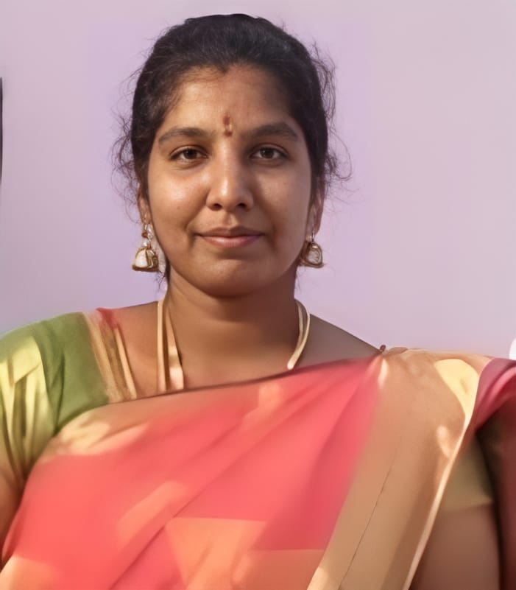
10 | 2697641994 | 1-44925151400 | Dr CHRIS LETTECIA MARY CHRISTOPHER JAYA,  Assistant Professor | 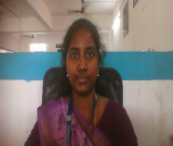
11 | 2675811984 | 1-44716147543 | Dr LAKSHMI SADHASIVAM  Assistant Professor | 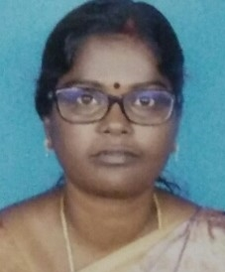
12 | 2651161997 | 1-46647645392 | Dr BHARATHI M N,  Assistant Professor | 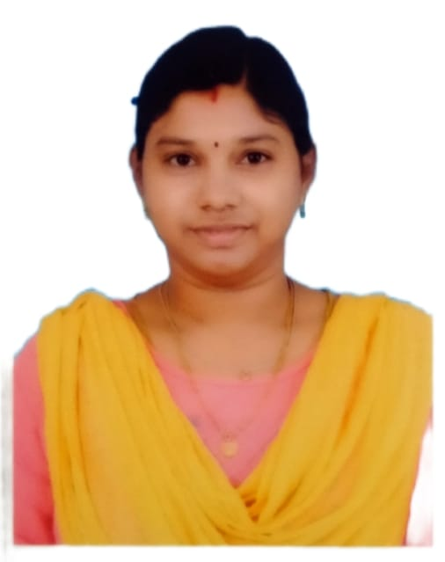
13 | 2658531991 | 1-47453627482 | Dr THANGADURAI K,  Assistant Professor | 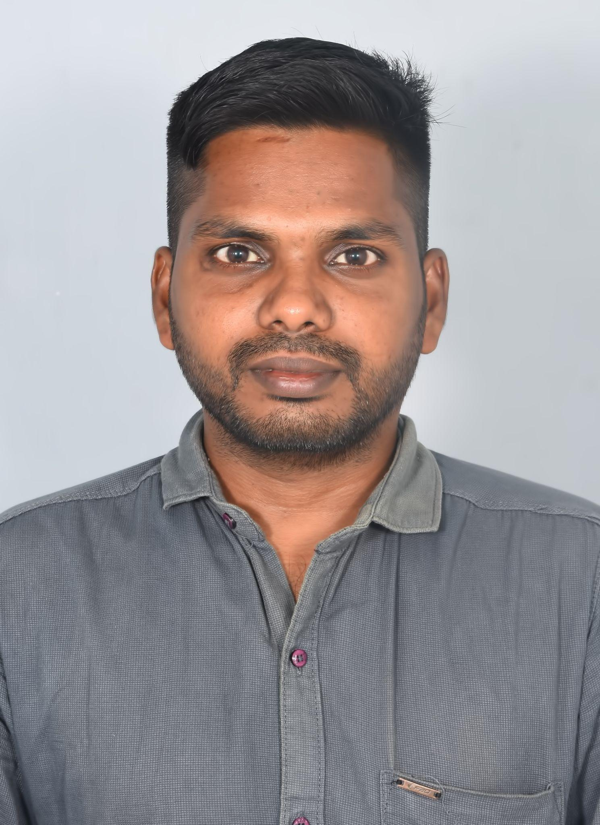

14 | 2650341993 | 1-10558757721 | Dr BENCY P EMMANUEL,  Assistant Professor | 
15 | 2620081991 | 1-44726501334 | Dr DURGADEVI R,  Assistant Professor | 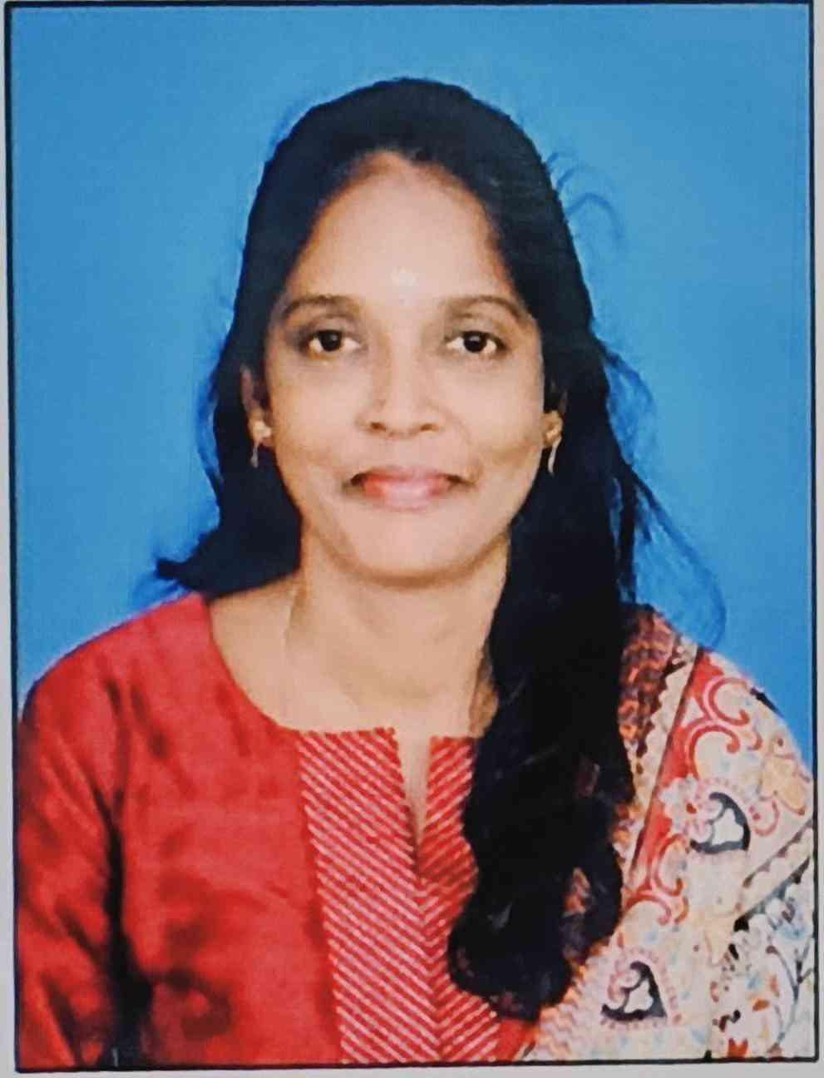
16 | 2651741983 | 1-3592989768 | Ms STELLA MARY S,  Assistant Professor | 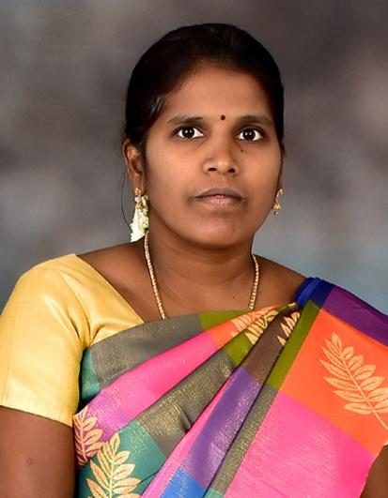
17 | 2624991996 | 1-11422797193 | Ms THARANI K,  Assistant Professor | 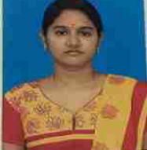
18 | 2618452001 | 1-45331744682 | Ms JENI SAJITHA J,  Assistant Professor | 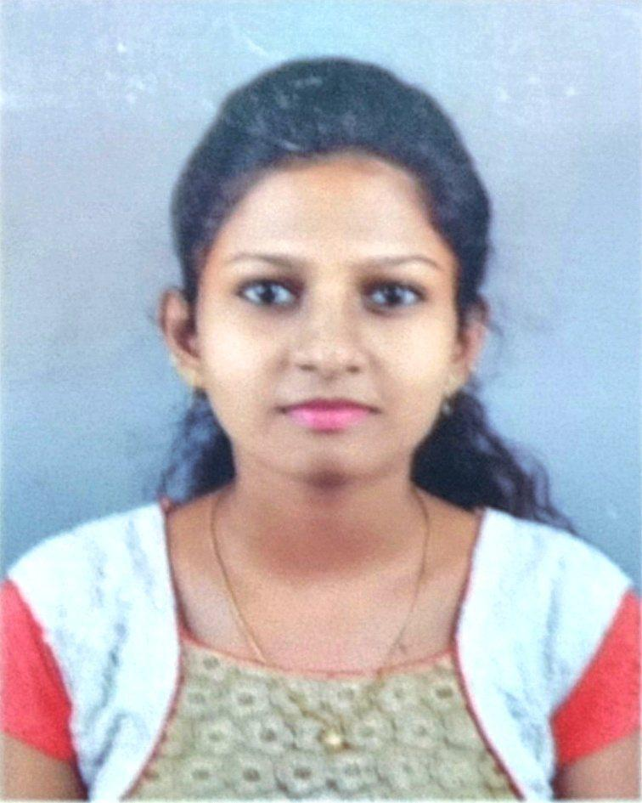
19 | 2626571994 | 1-47940371681 | Mrs ARATHY SUNIL,  Assistant Professor | 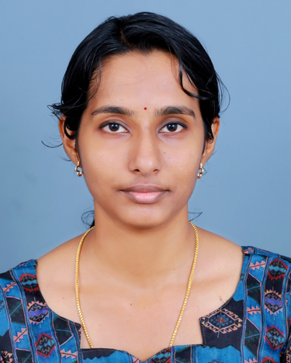
20 | 2655271987 | 1-47940371701 | Mr KIRUBHASHANKAR,  Assistant Professor | 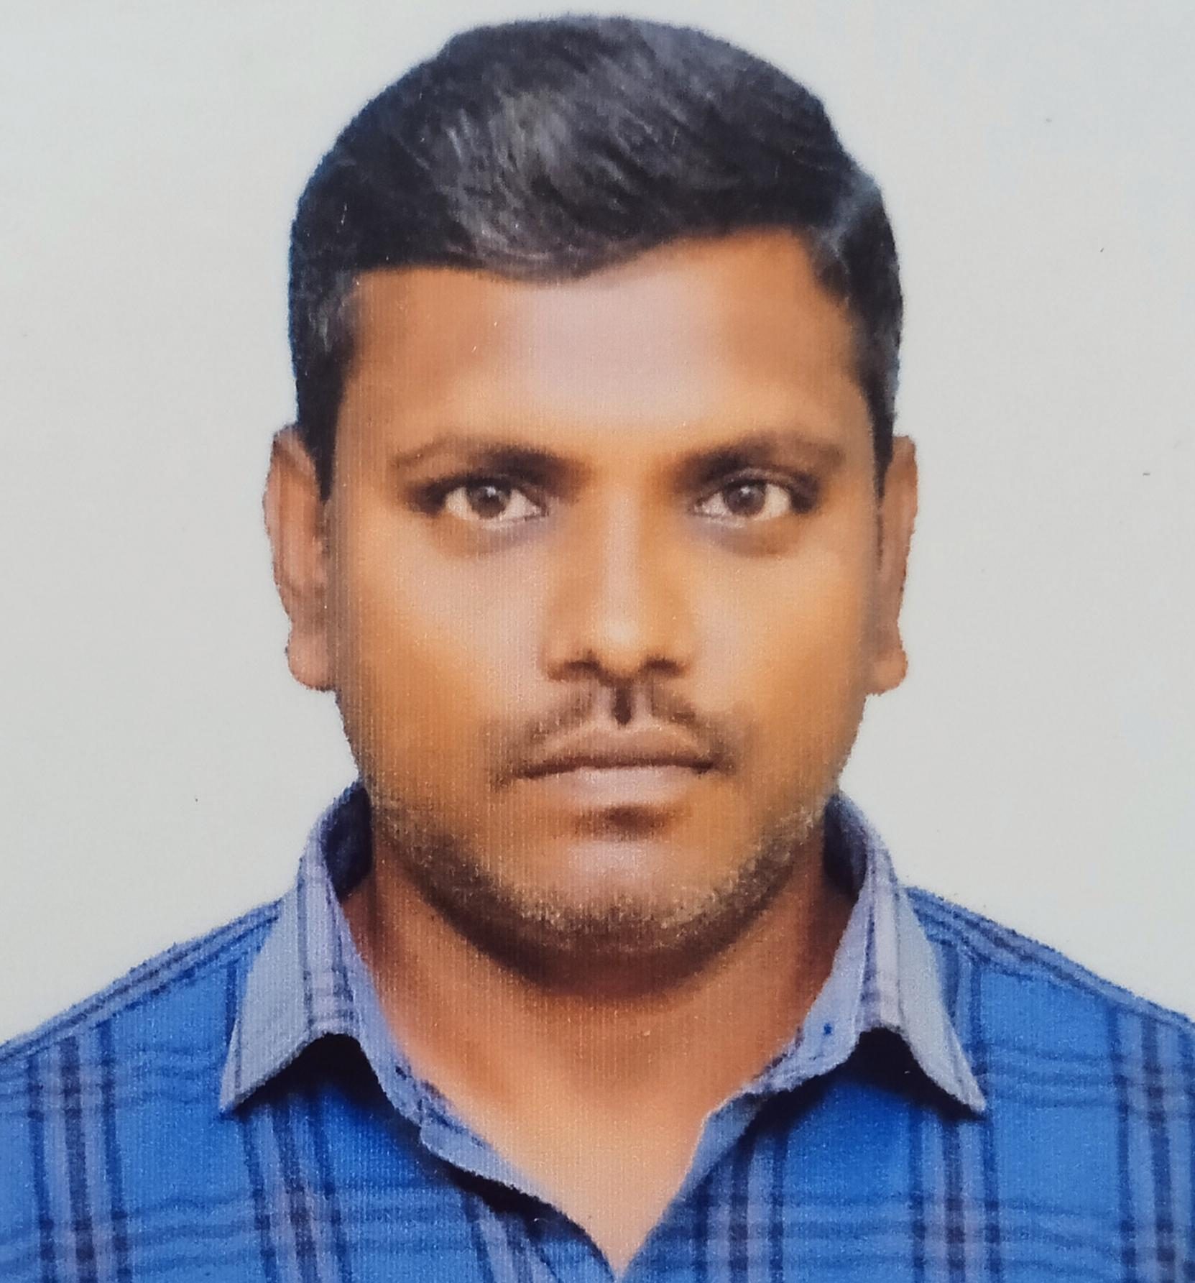

21 |  | 2624431996 |  | 1-9551201832 | Ms ANITHA M  Assistant professor |  | 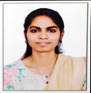
22 |  | 2661301990 |  | 1-2944854972 | Mr PRADEEP,  Assistant Professor |  | 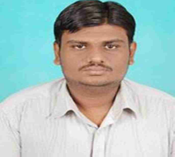
23 |  | 2622071991 |  | 1-10989916686 | Ms ANUSHYA G,  Assistant Professor |  | 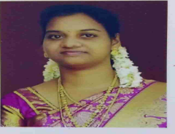
 | 24 |  | 2673931988 | 1-43899978821 |  | Mr SYED FEROZ,  Assistant Professor | 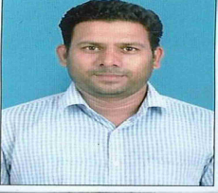
 | 25 |  | 2692261990 | 1-47932788928 |  | Dr NASREEN SULTANA A,  Assistant Professor
 | 26 |  | 2642761988 |  |  | Dr HEMAVATHY S,  Assistant Professor | 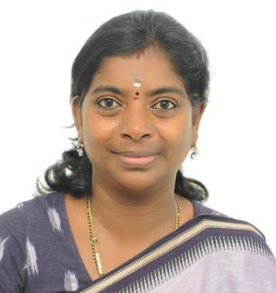
 | 27 |  | 2655831998 |  |  | Mrs ANISHA RAJENDRAN,  Assistant Professor | 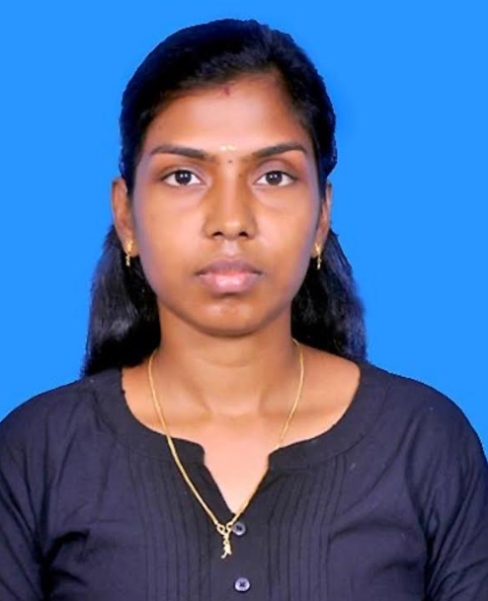
 | 28 |  | 2623441985 |  |  | Mrs RUTHJENILA M,  Assistant Professor | 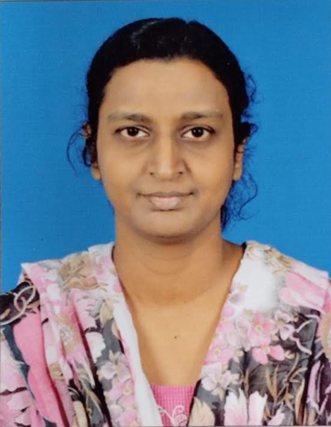
 | 29 |  | 2631101990 |  |  | Mr ALDO SHIBIN  Assistant Professor
 | 30 |  | 2794401993 |  |  | Mrs SHYLAJA H S  Assistant Professor

